**cloud computing**

**LAB 05**

**Name:** Abiha Nadeem

**Roll no:** 2023-BSE-001

**Submitted to:** Engr. Muhammad Shoaib

**Task 1 - Discover missing command & install Java using apt suggestion**

**Goal: Run the java command when it's not installed, follow the system suggestion to install a Java package using apt, verify, then remove and clear shell cache.**

**Steps (inside the VM terminal)**

1. Run the java command to see what the system suggests:

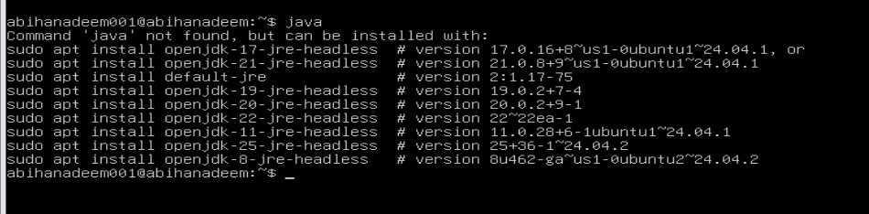

1. Use the suggested apt command (copy the exact package name suggested by the system). Example (replace with the name shown on your VM):

sudo apt install <suggested-package> -y

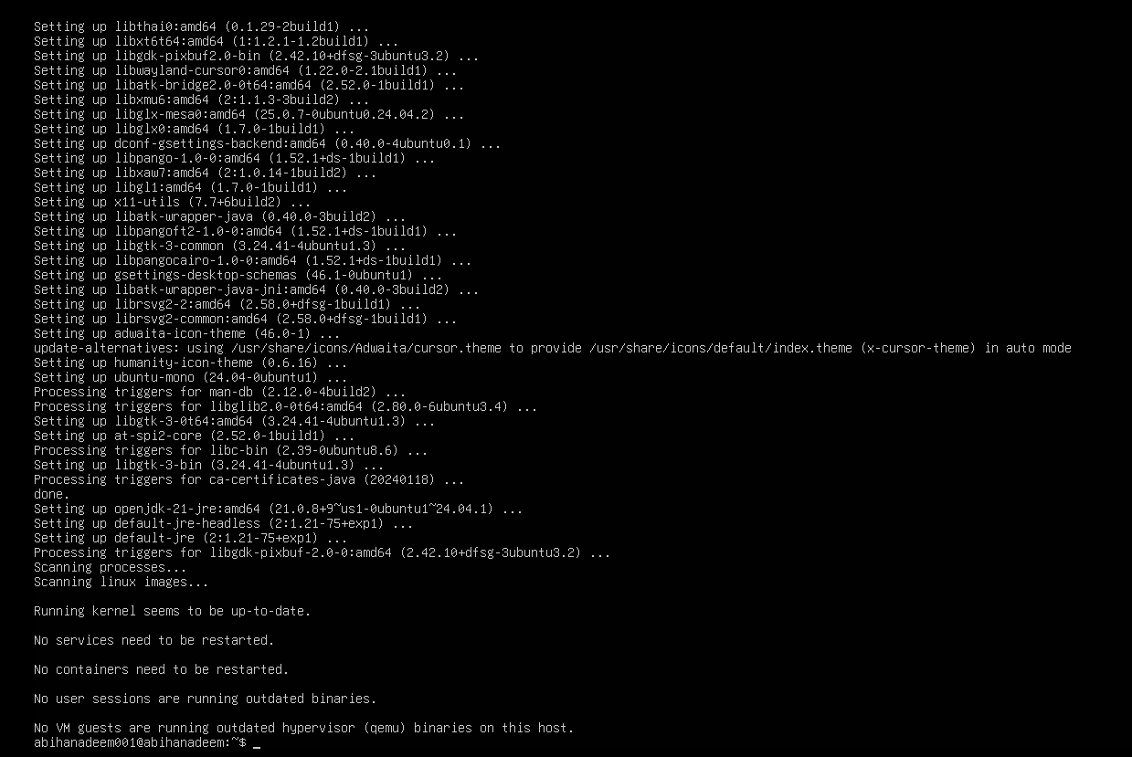

1. Verify Java is installed and check version:

java --version

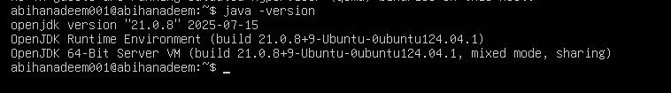

1. Remove the Java package using apt remove (use the same package name you installed):

sudo apt remove <suggested-package> -y

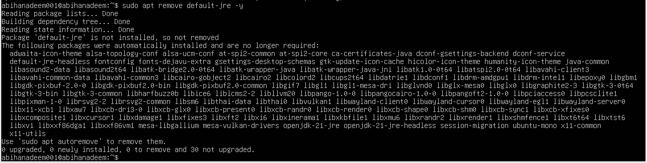

1. Confirm java is no longer available (run java again) — it should again indicate "not found" or suggest installation:

java



1. Clear the shell's command hash cache so the shell forgets cached command locations (run as your regular user — no sudo required):

hash -r

java

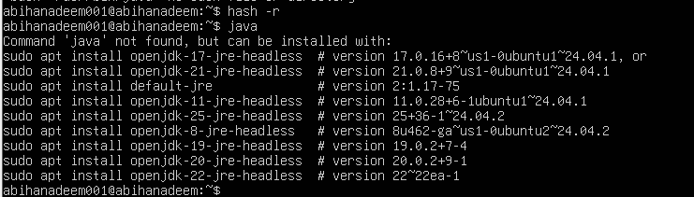

**Task 2 - Install & remove Java using apt-get (explicitly)**

Goal: Repeat install/remove using the apt-get tool to show both package managers.

**Steps (inside VM terminal)**

1. Install Java using apt-get (choose a common package, e.g., default-jre — or the same package you used in Task 1):

sudo apt-get update

sudo apt-get install default-jre -y

* Save screenshot(s) as: task2_aptget_install.png

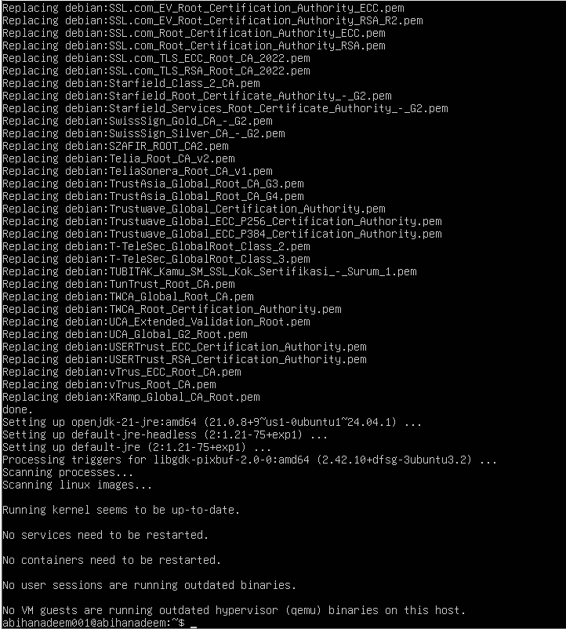

1. Verify Java version again:

java --version

* Save screenshot as: task2_java_version_after_aptget.png

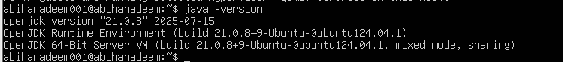

1. Remove Java using apt-get remove:

sudo apt-get remove default-jre -y

* Save screenshot as: task2_aptget_remove.png

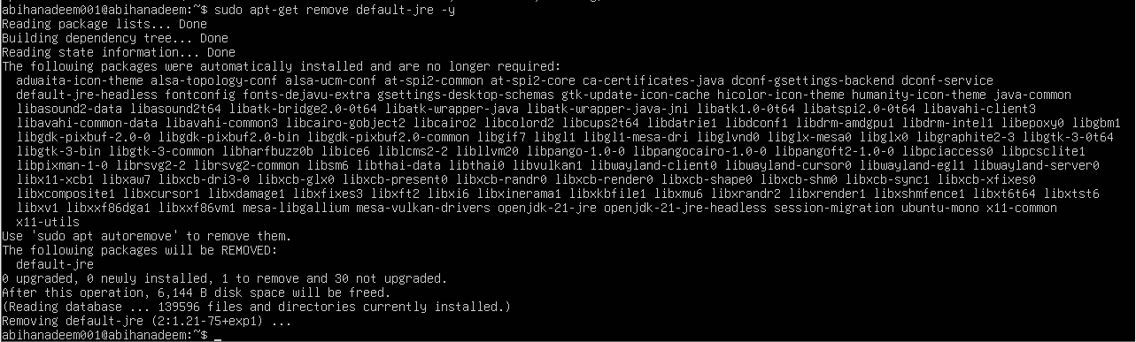

1. Clear the terminal hash cache and confirm java is missing:

hash -r

java

* Save screenshot as: task2_hash_after_remove.png

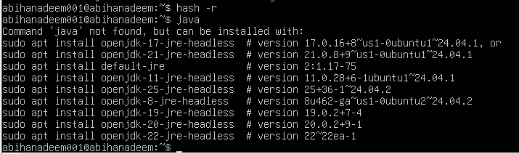

**Task 3 - apt update vs apt upgrade - run & explain**

Goal: Run the commands and document the difference.

**Steps (inside VM terminal)**

1. Update the package index (this downloads the latest lists of available packages):

sudo apt update

* Save screenshot as: task3_apt_update.png

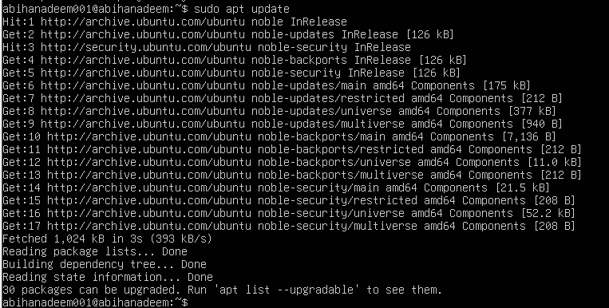

1. Upgrade installed packages (this installs available updates for currently installed packages):

sudo apt upgrade

* Save screenshot as: task3_apt_upgrade.png

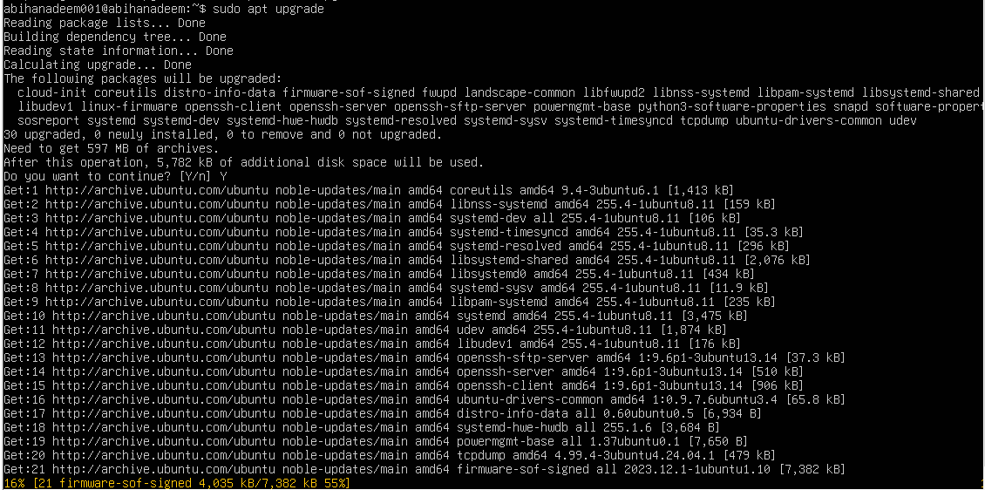

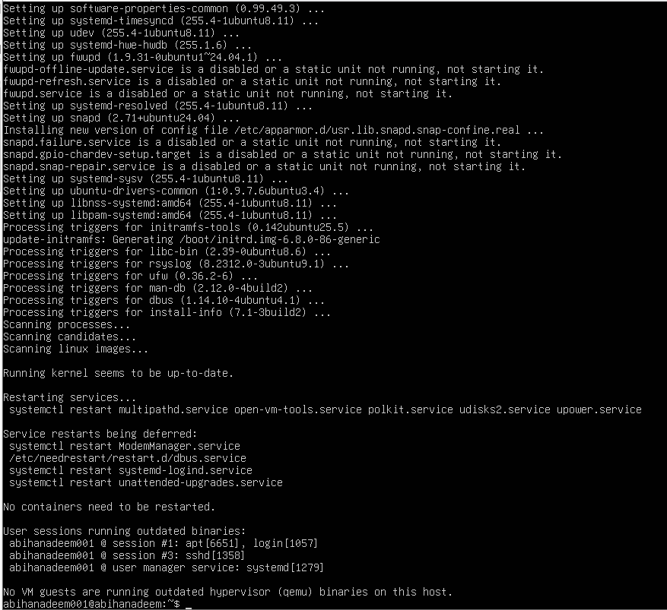

1. Write a short 3–5 sentence explanation describing the difference between apt update and apt upgrade. Put your text into a small file and capture it as a screenshot (do not upload the text file; provide the screenshot):

nano ~/apt_update_vs_upgrade.md

# write 3-5 sentences, save and exit

* Open the file or show it on screen and save screenshot as: task3_explanation.png



**Task 4 - Install Visual Studio Code via snap on CLI and verify (DO NOT remove Code)**

Goal: Install a snap package (example: VS Code) on a CLI-only server and verify installation using commands that work without a GUI. Keep Code installed for later GUI tasks.

**Steps (inside VM terminal)**

1. Install VS Code via snap (snap may require sudo):

sudo snap install --classic code

* Save screenshot as: task4_snap_install.png

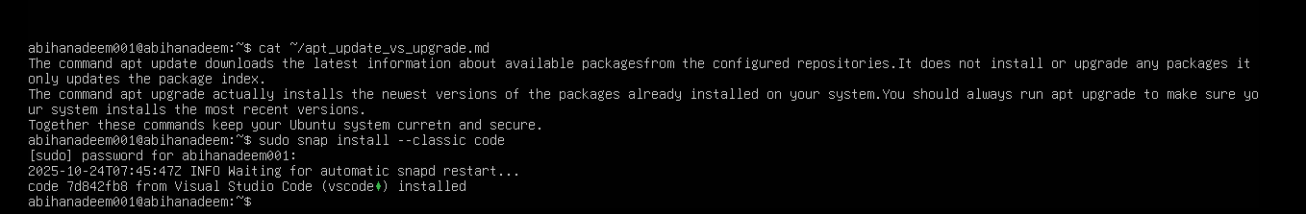

1. Verify snap shows the package is installed:

snap list code

* Save screenshot as: task4_snap_list.png

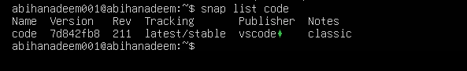

1. Check the installed application's version. On some systems code --version is available; also check snap info:

code --version

* Save screenshot(s) as: task4_code_version_or_info.png

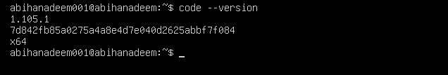

1. If the code binary is not in PATH, show where the snap placed it:

ls -l /snap/bin | grep code

* Save screenshot as: task4_snap_bin_location.png

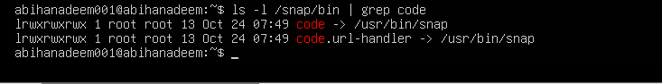

**Task 5 - Install XFCE GUI + XRDP - minimal desktop and remote access (GUI) and launch VS Code**

Goal: Install a lightweight GUI (XFCE), enable XRDP for remote desktop access, and learn how to control whether the GUI login screen appears at boot. After starting the GUI, launch the VS Code installed in Task 4 to verify GUI app launch. This task is for this lab.

Warning: Installing a GUI on a server consumes additional disk space and memory. Perform on a VM with sufficient resources.

**Steps (inside the host terminal / via SSH)**

1. From your host, open your preferred terminal (for example: Windows Command Prompt, PowerShell, macOS Terminal, or Linux Terminal) and connect to the VM using SSH. Example:

ssh student@<vm-ip-address>

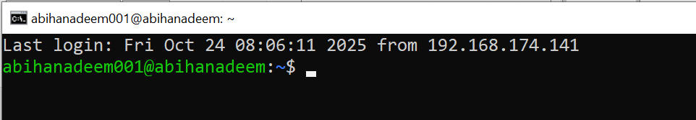

2. Update the server (download package lists and apply upgrades):

sudo apt update && sudo apt upgrade -y

* 1. Save screenshot as: task5_update.png

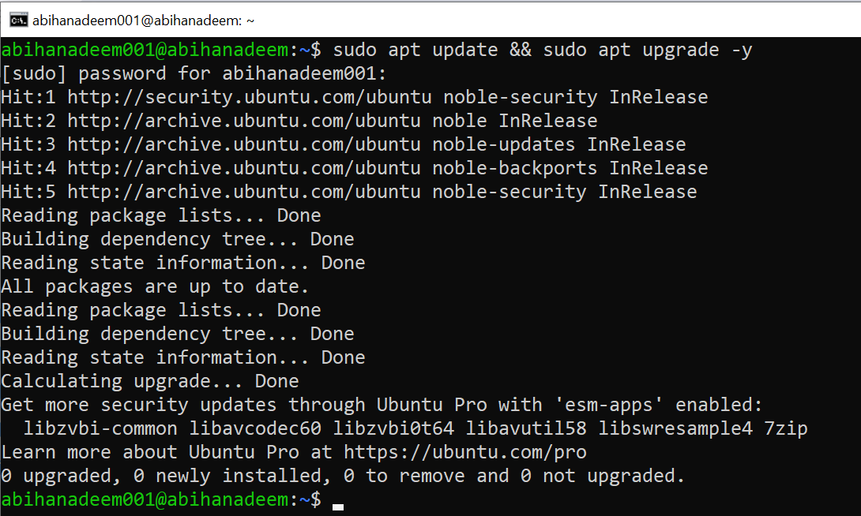

3. Install XFCE and XFCE goodies (lightweight desktop):

sudo apt install xfce4 xfce4-goodies -y

* 1. Save screenshot as: task5_xfce_install.png

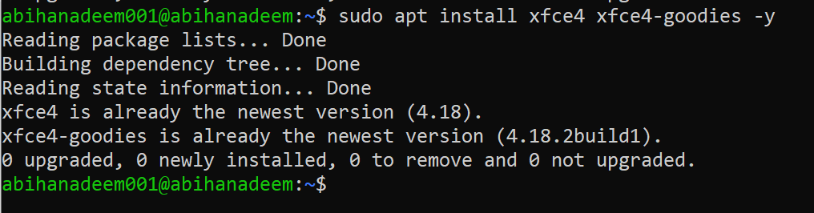

4. Install and enable XRDP (Remote Desktop Protocol server):

sudo apt install xrdp -y

sudo systemctl enable --now xrdp

* 1. Save screenshot as: task5_xrdp_enable.png

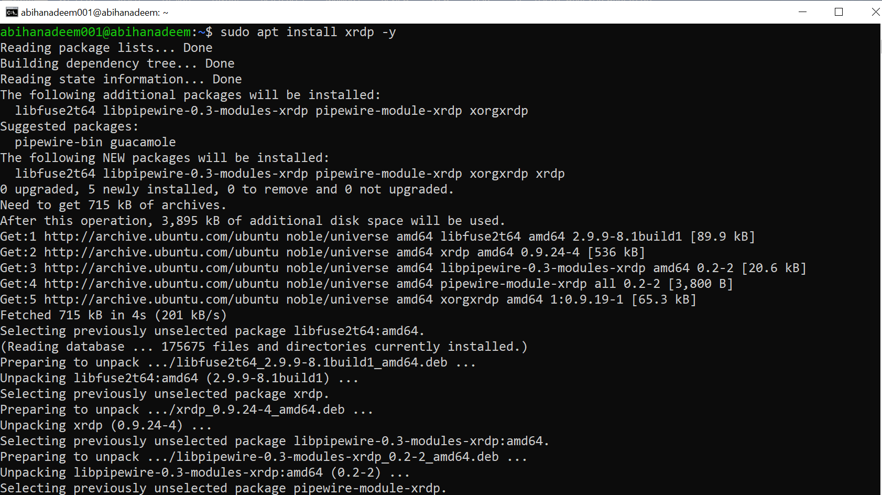

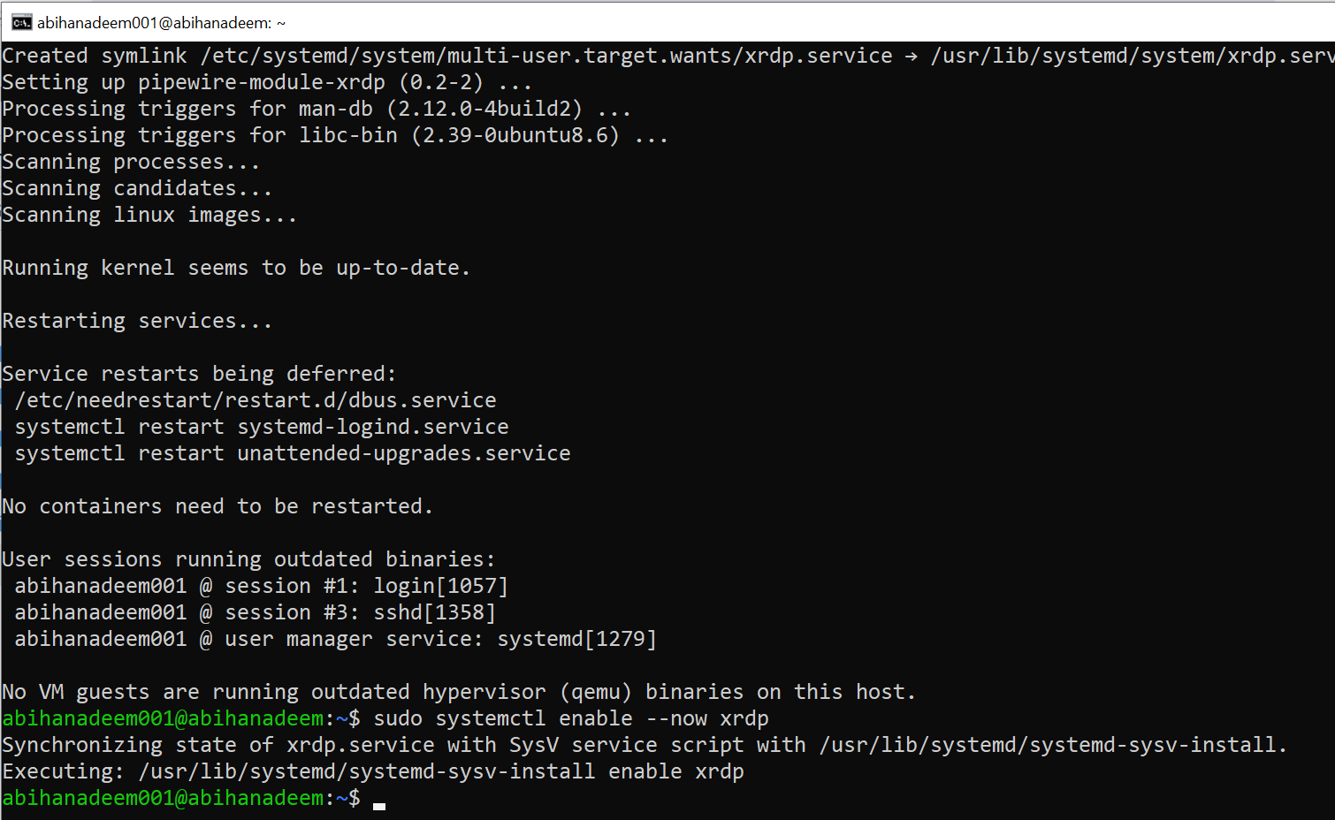

5. Verify XRDP status:

sudo systemctl status xrdp

* 1. Save screenshot as: task5_xrdp_status.png

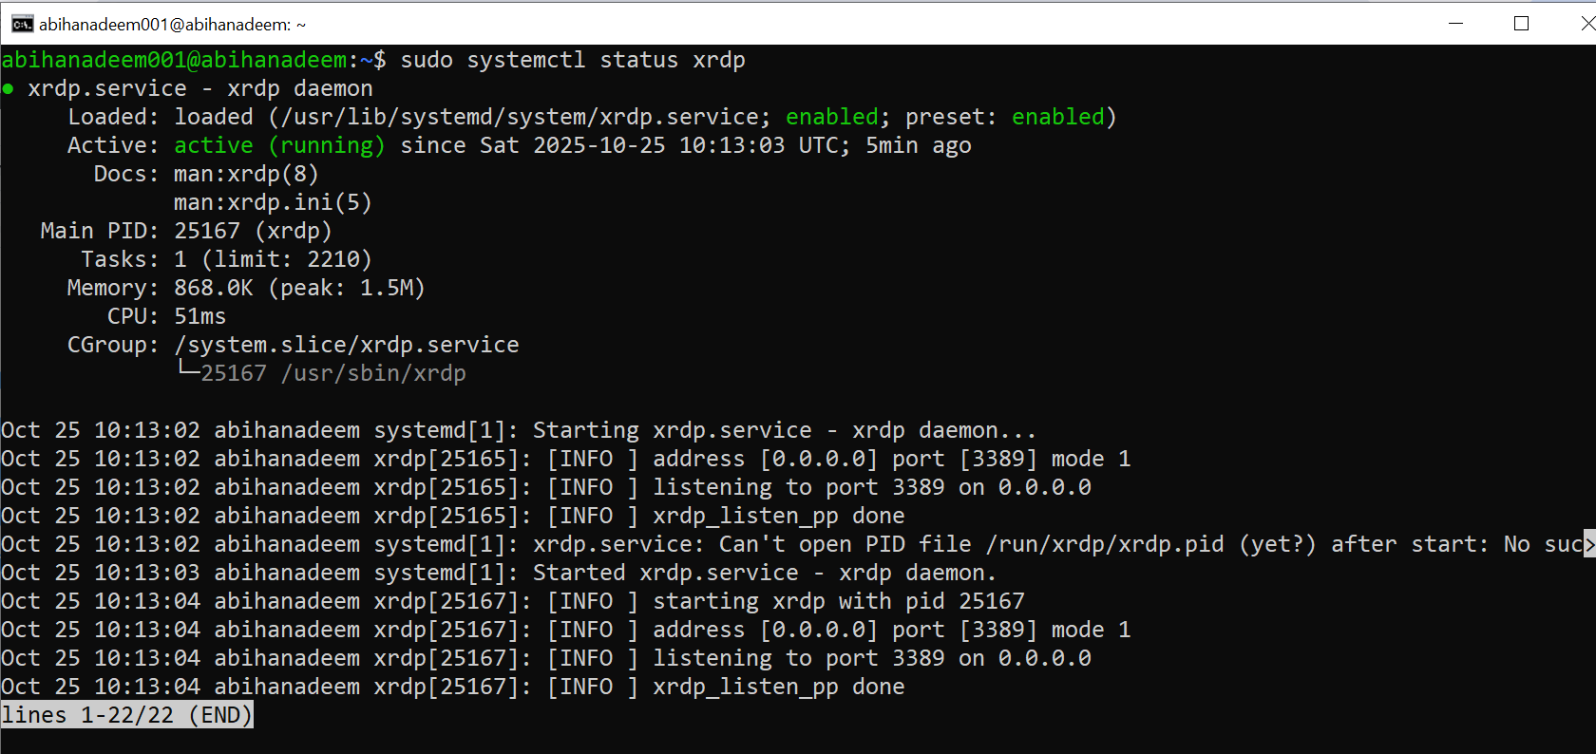

6. Configure XRDP to use XFCE session:

echo xfce4-session > ~/.xsession

* 1. Save screenshot as: task5_xsession.png

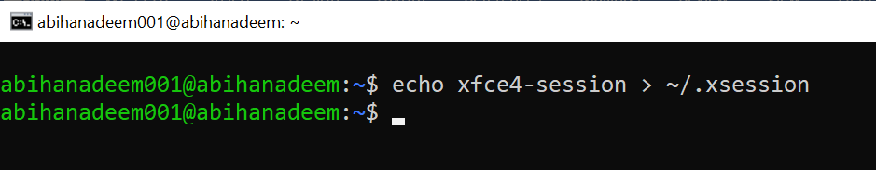

7. From a Windows host or RDP client, connect with Remote Desktop (mstsc) to your server IP and login using your Ubuntu username/password. Capture a screenshot of the remote desktop or the RDP session window (if allowed by your environment) and save it as: task5_rdp_connect.png

If you cannot capture a screenshot from the client, show ss -ltnp or ps evidence that the session was established and save as an alternative.

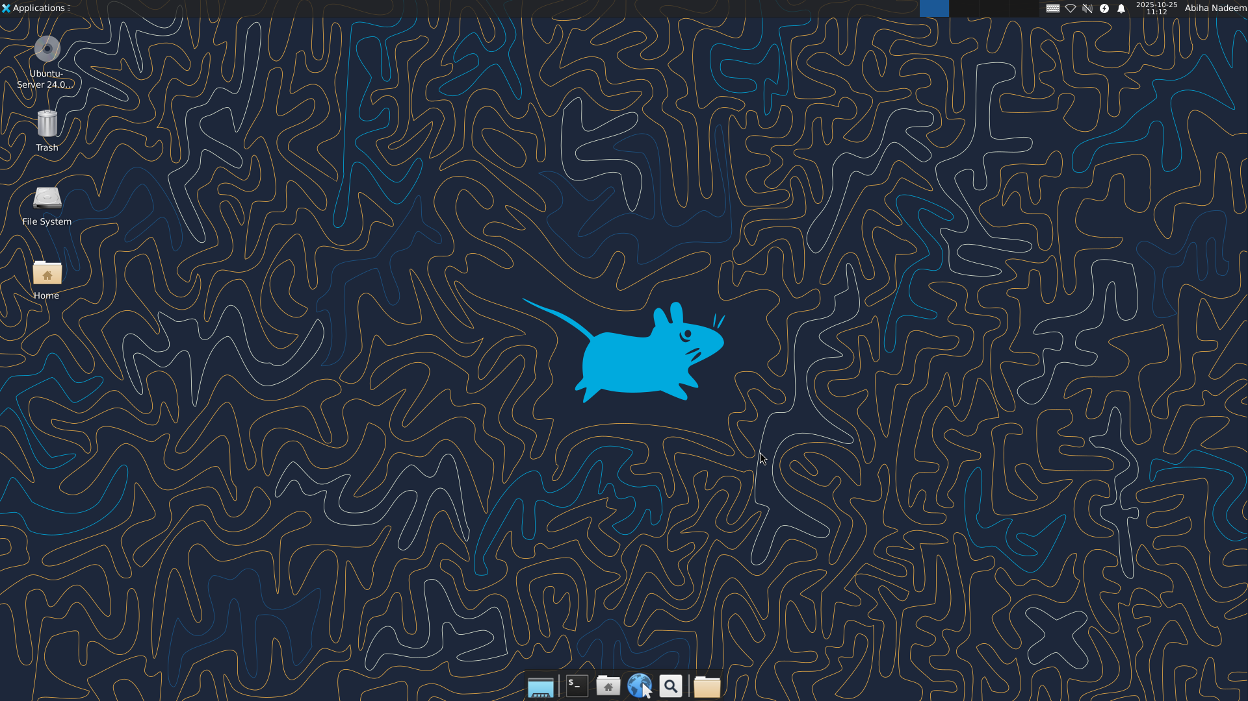

8. After you are in the GUI (local console or RDP session), launch Visual Studio Code (installed in Task 4) from the GUI menu or a terminal inside the GUI. Example command from a GUI terminal:

code

* Save a screenshot of VS Code running in the GUI as: task5_vscode_launch.png

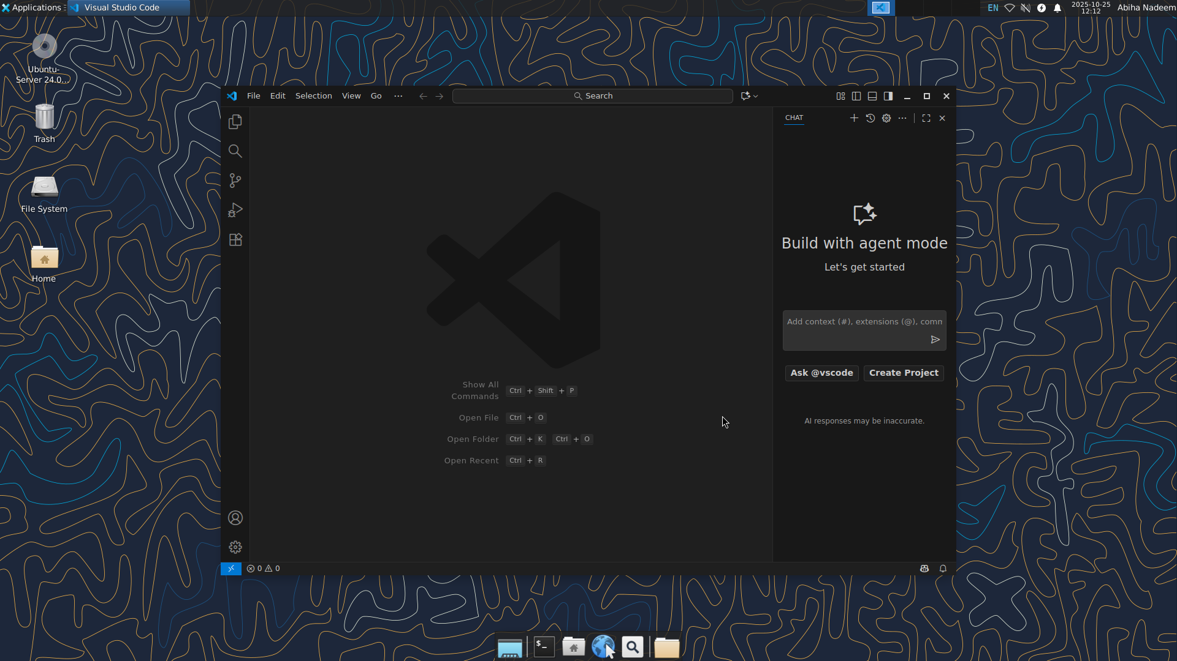

**Task 6 - Install lightdm-gtk-greeter and GUI verification - start GUI, open VS Code, take snapshot, then end (GUI)**

**Steps (inside the host terminal / via SSH)**

1. Fix GUI login screen issues (if lightdm / greeter problems appear)

* Install LightDM and greeter using Host Terminal:

sudo apt install lightdm lightdm-gtk-greeter -y

* Save screenshot as: task6_lightdm_install.png

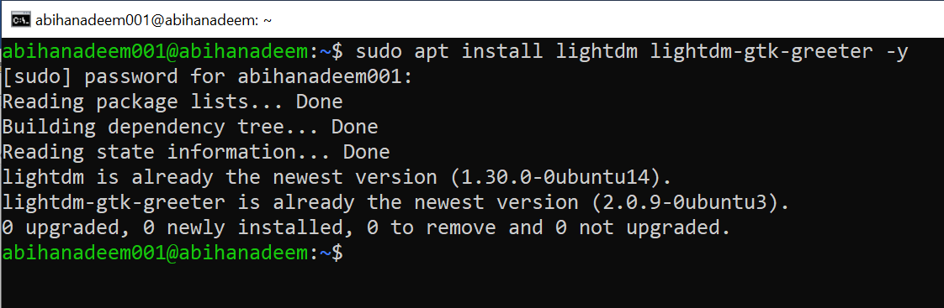

* Create LightDM config to use XFCE:

sudo mkdir -p /etc/lightdm/lightdm.conf.d

echo -e "[Seat:*]\ngreeter-session=lightdm-gtk-greeter\nuser-session=xfce\nautologin-user-timeout=0" | sudo tee /etc/lightdm/lightdm.conf.d/99-xfce.conf

* Save screenshot as: task6_lightdm_config.png

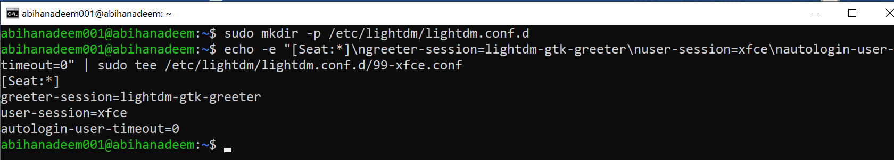

* Clean up problematic session files and permissions:

sudo rm -f /var/lib/lightdm/.Xauthority

sudo rm -f ~/.Xauthority

sudo rm -rf ~/.cache/sessions

sudo chown -R $USER:$USER /home/$USER

* Save screenshot as: task6_lightdm_cleanup.png

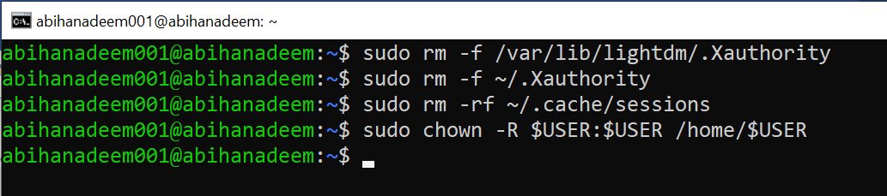

* Restart LightDM:

sudo systemctl restart lightdm

* Save screenshot as: task6_lightdm_restart.png

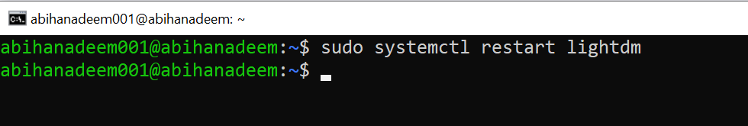

1. Control GUI login at boot — ENABLE first, then DISABLE (observe and understand terminal/GUI behavior after each reboot)

Important: students MUST perform the reboot after each target change to observe the boot-time behavior. The sequence below has been adjusted so you ENABLE the GUI boot target first, reboot and observe GUI, then DISABLE the GUI boot target, reboot and observe the CLI.

* Enable GUI Login Screen (Boot to GUI)
  + Re-enable LightDM and set the graphical target as default:

sudo systemctl enable lightdm

sudo systemctl set-default graphical.target

* Save a screenshot immediately after running the commands as: task6_gui_enable_boot.png

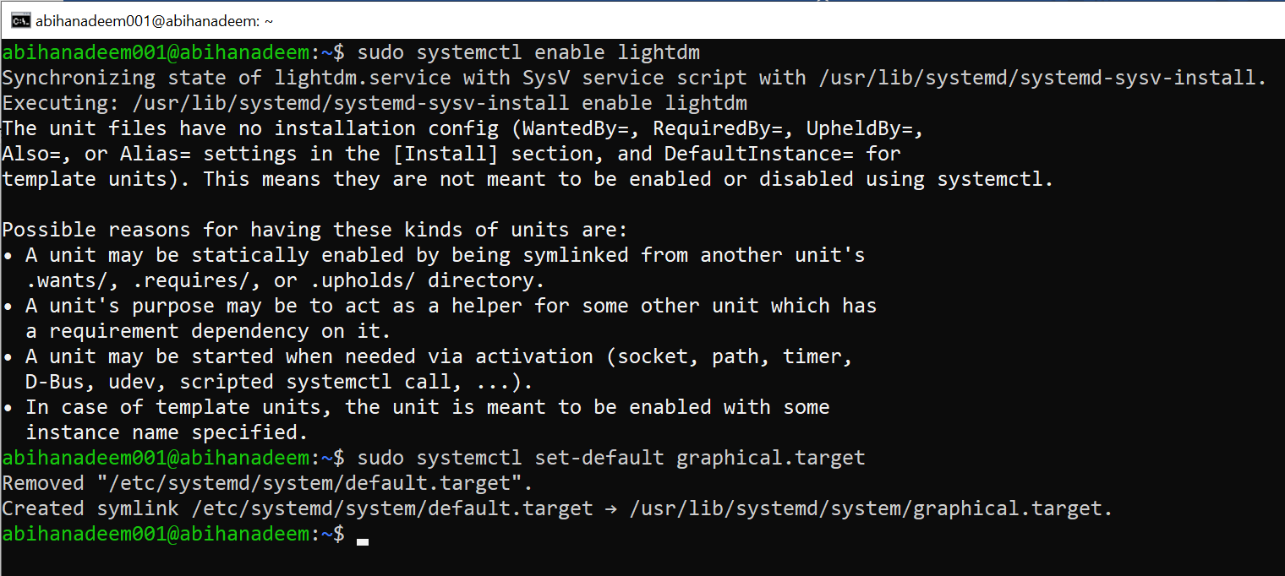

* Reboot the VM to observe that it boots to the GUI login screen:

sudo reboot

* After the VM boots, capture a screenshot of the GUI login screen (or remote desktop showing the greeter) and save it as: task6_after_reboot_gui.png

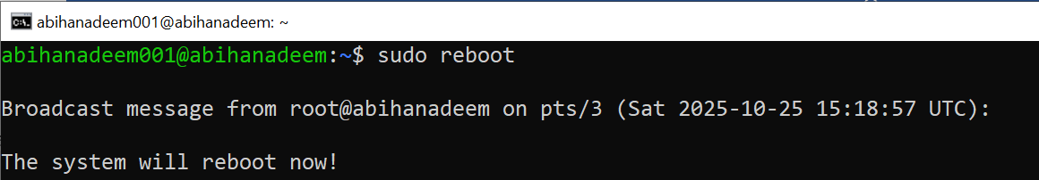

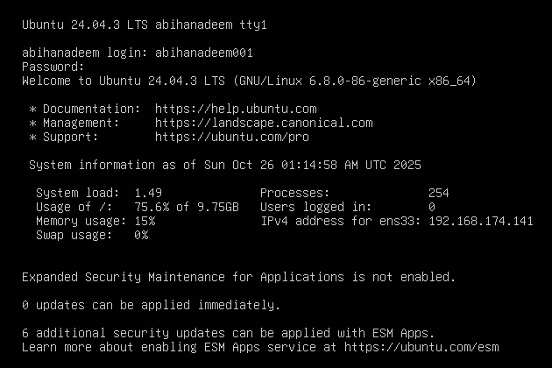

* Disable GUI Login Screen (Boot to CLI)
  + Set the default boot target to multi-user (text mode) and disable LightDM so the system boots to the terminal:

sudo systemctl set-default multi-user.target

sudo systemctl disable lightdm

* Save a screenshot immediately after running the commands as: task6_gui_disable_boot.png

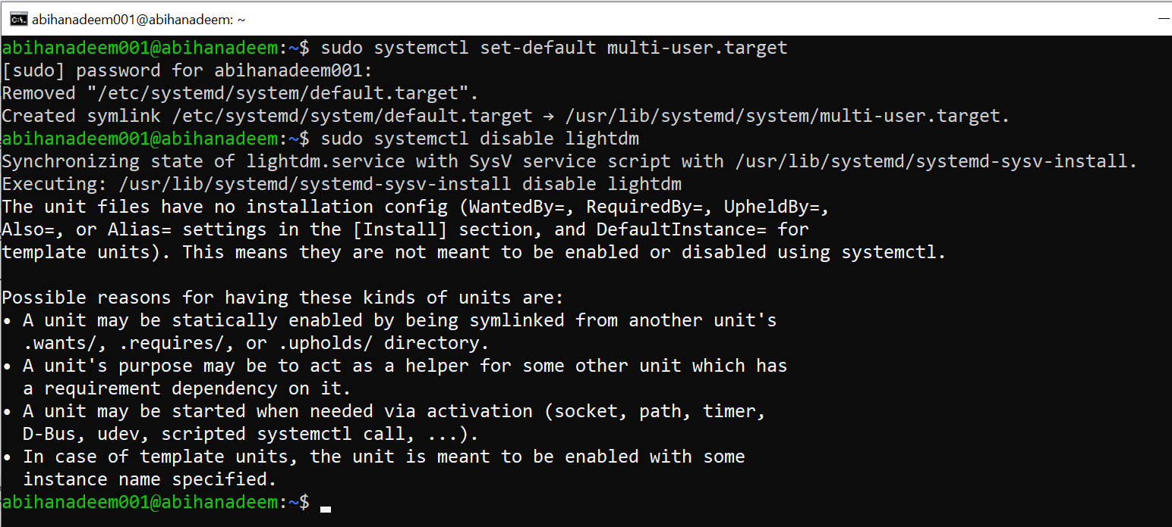

* Reboot the VM to observe that it boots to the terminal (CLI):

sudo reboot

* After the VM boots, capture a screenshot of the login prompt or terminal session showing CLI-only behavior and save it as: task6_after_reboot_cli.png

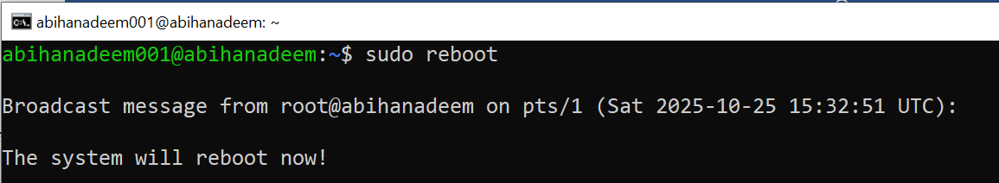

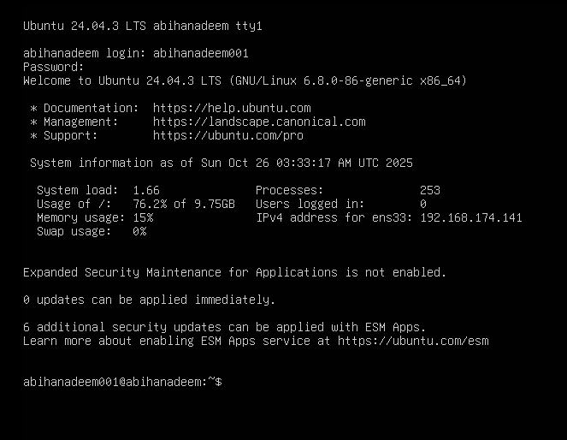

* Start/Stop GUI manually (no reboot)
  + You can start the GUI session without changing the boot target. This is useful if you want to keep the boot target as CLI but run GUI temporarily:
  + Save screenshot(s) showing the start commands and any immediate status output as: task6_gui_start.png

sudo systemctl start lightdm # start GUI now

* Press Ctrl + Alt + F3 to switch back to TTY. You can stop the GUI session without changing the boot target.

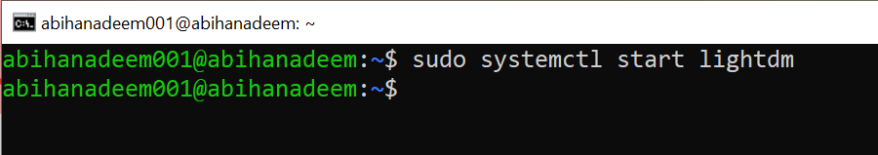

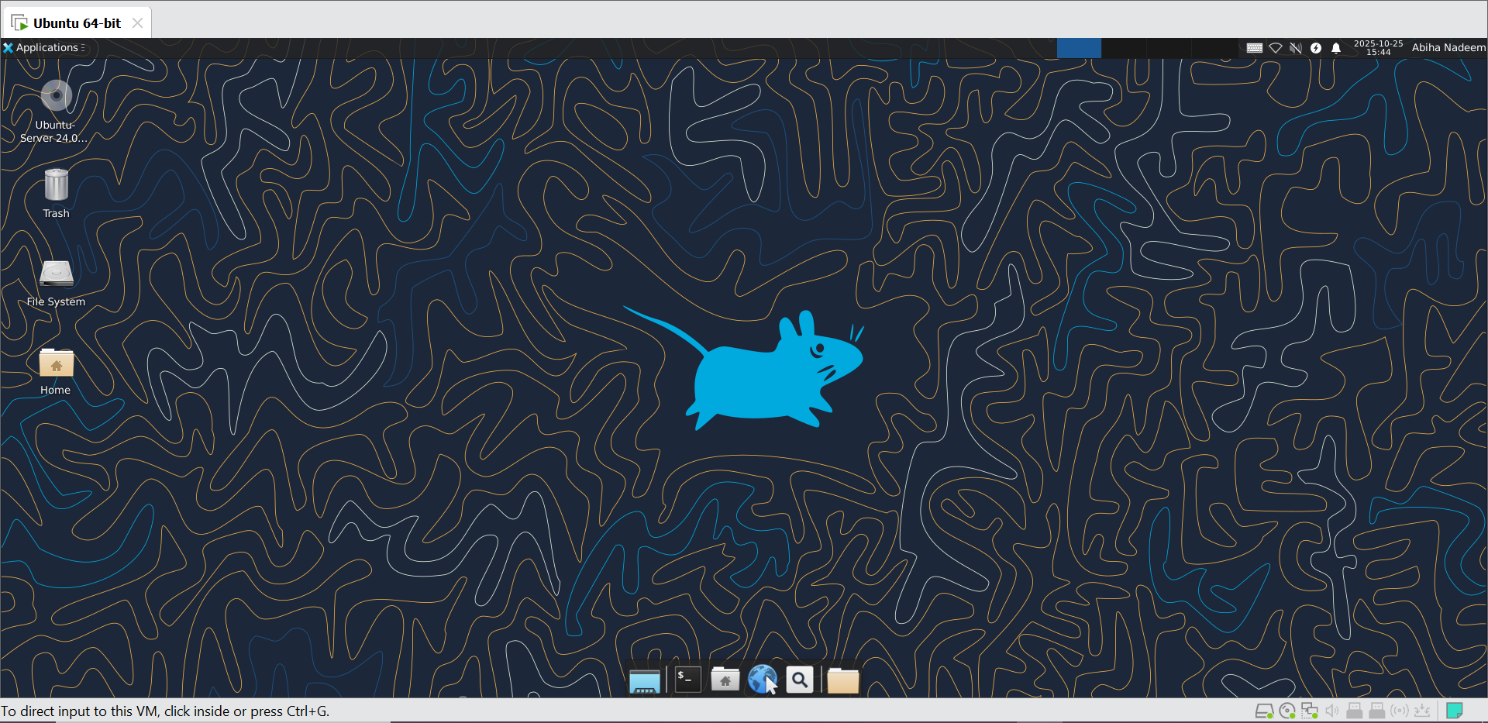

sudo systemctl stop lightdm # stop GUI now

* Save screenshot(s) showing the start/stop commands and any immediate status output as: task6_gui_stop.png

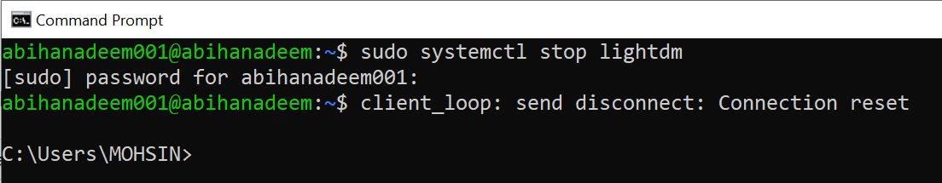

1. Start the GUI (if the system is currently set to CLI or the GUI is not running):

sudo systemctl start lightdm

* Save a screenshot immediately after running the command as: task6_gui_start_command.png

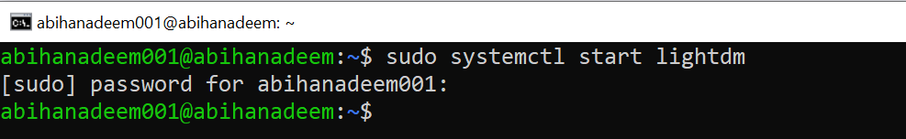

1. In the GUI session launch Visual Studio Code (installed earlier in Task 4). From a GUI terminal inside the desktop, run:

code

* Save a screenshot of VS Code running in the GUI as: task6_vscode_launch.png

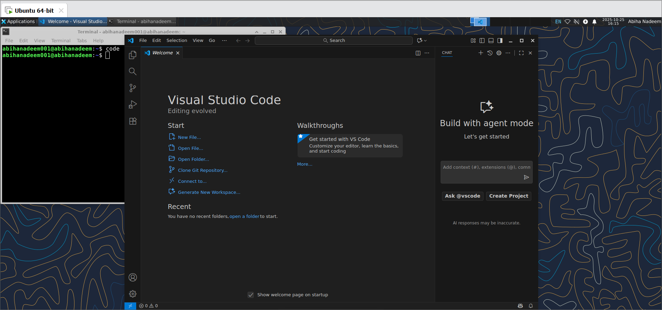

1. Close VS Code using the GUI window controls. Task 6 ends here.

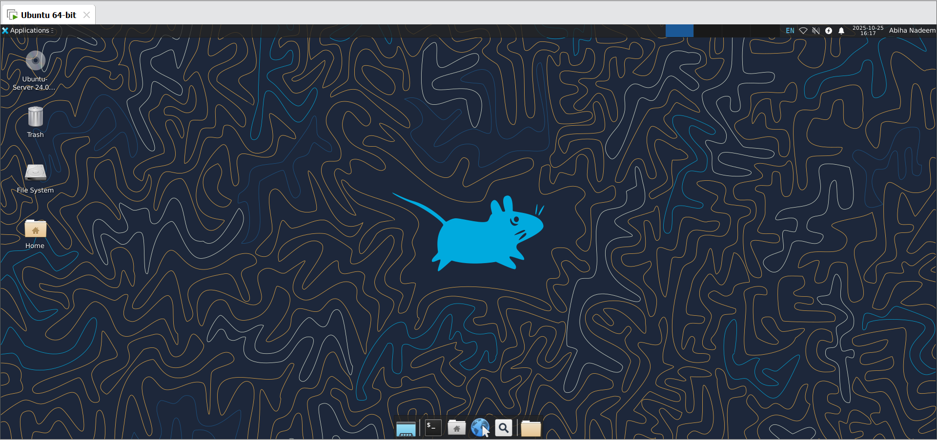

**Task 7 - Install Google Chrome by adding its apt source & key (Chrome)**

Goal: Add Google's apt source and signing key so that sudo apt install google-chrome-stable succeeds. This task intentionally begins by attempting to install Chrome directly (the install will fail if the repository/key are not yet configured) — capture that failure as evidence, then proceed to add the repository/key and install successfully. Also includes an alternate (preferred) one-line list method.

IMPORTANT: Third-party repositories require trusted signing keys. Only add keys from official vendor URLs. Some systems require /etc/apt/keyrings to exist — create it if missing with sudo mkdir -p /etc/apt/keyrings.

**Steps (inside the VM terminal or GUI terminal or host terminal / via SSH)**

1. (Learning step — first command must be the install attempt) Attempt to install Google Chrome directly to see the failure when the repo/key are missing:

sudo apt install google-chrome-stable -y

* Expected: this will typically fail with "Unable to locate package google-chrome-stable" or similar because the Google repo/key are not yet configured.
* Save a screenshot of the error output as: task7_install_chrome_error.png

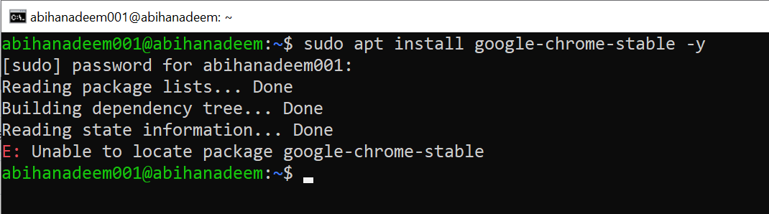

1. Inspect apt configuration so you understand why install failed. List the /etc/apt directory:

ls -la /etc/apt

* Save screenshot as: task7_ls_etc_apt.png

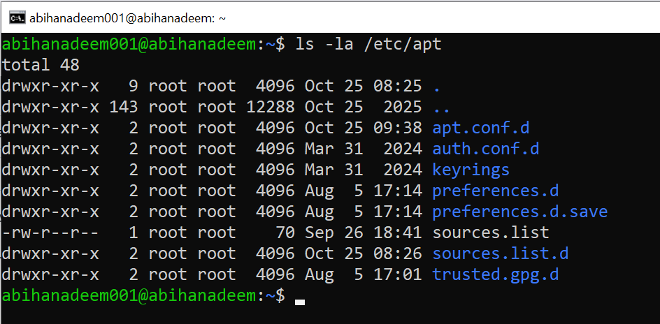

1. View the main /etc/apt/sources.list:

cat /etc/apt/sources.list

* Save screenshot as: task7_cat_sources_list.png

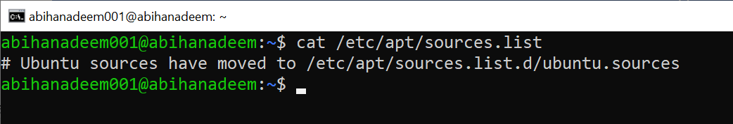

1. List files under /etc/apt/sources.list.d:

ls -la /etc/apt/sources.list.d/

* Save screenshot as: task7_ls_sources_list_d.png

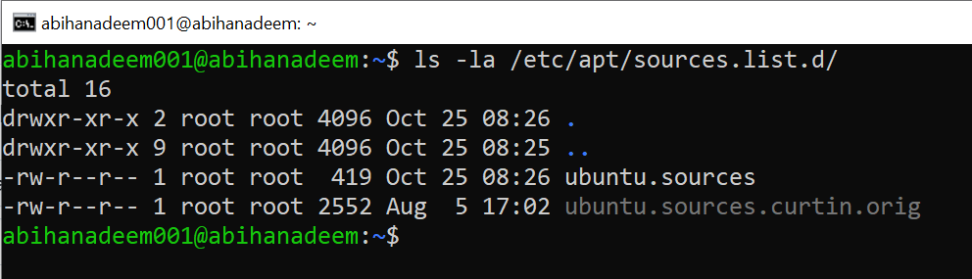

1. If there is a file named ubuntu.sources (or similarly named source file), display it to see whether Chrome's repo is present:

cat /etc/apt/sources.list.d/ubuntu.sources

* Save screenshot as: task7_cat_ubuntu_sources.png

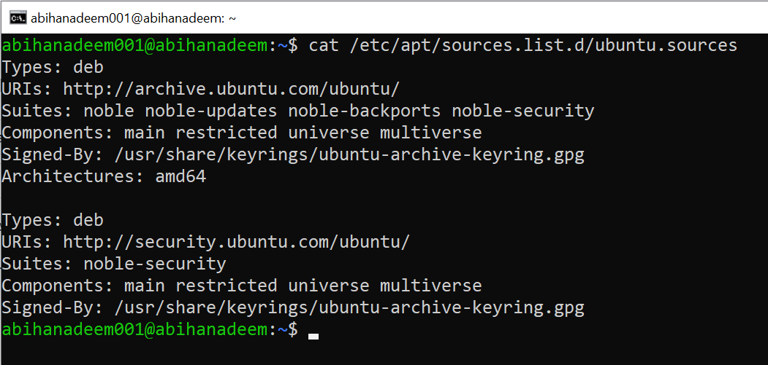

1. Add Chrome repository metadata to a sources file (method A — using ubuntu.sources). Open or create the file and append the stanza (you can alternatively use the preferred one-line method in step 11):

sudo nano /etc/apt/sources.list.d/ubuntu.sources

* Append these exact lines at the end of the file:

Types: deb

URIs: http://dl.google.com/linux/chrome/deb/

Suites: stable

Components: main

Architectures: amd64

Signed-By: /etc/apt/keyrings/google.gpg

* Save the file (Ctrl+O → Enter) and exit (Ctrl+X).
* Save a screenshot after editing (or show the file contents with cat) as: task7_edit_ubuntu_sources.png

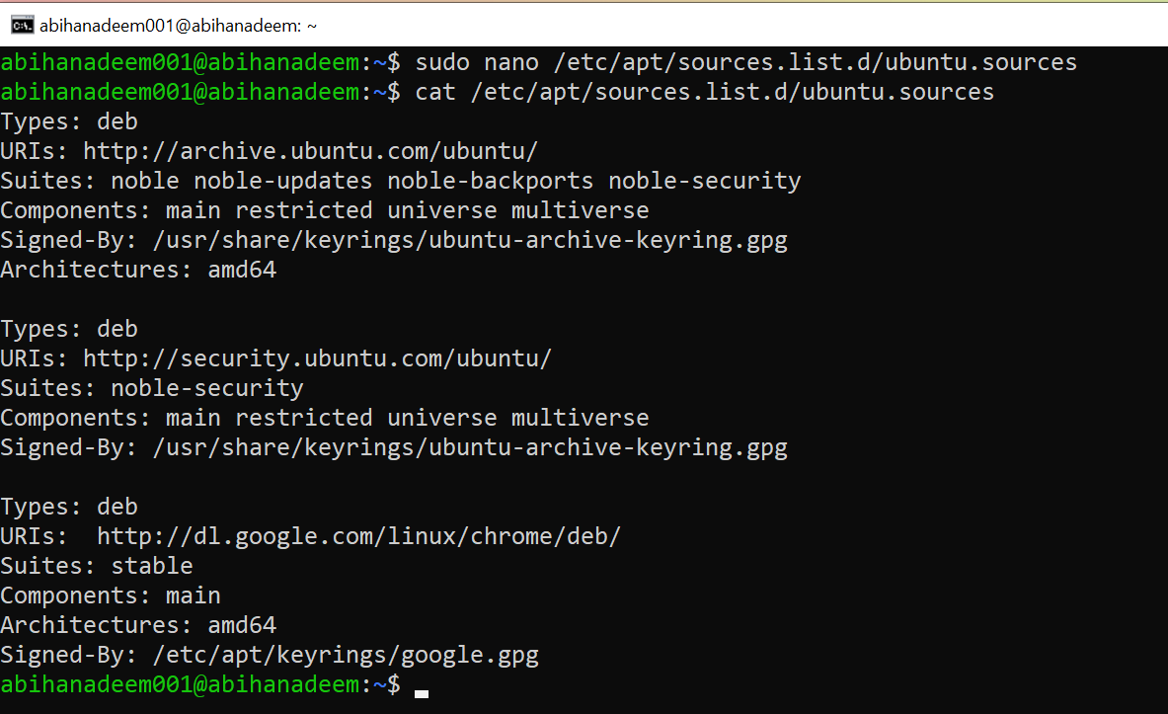

1. Ensure the keyrings directory exists and import Google's signing key:

curl -fsSL https://dl.google.com/linux/linux_signing_key.pub | sudo gpg --dearmor -o /etc/apt/keyrings/google.gpg

* Save screenshot as: task7_add_key.png



1. Update apt and attempt to install Chrome again (now that repo + key are added):

sudo apt update

sudo apt install google-chrome-stable -y

* Save screenshots as: task7_apt_update.png and task7_install_chrome.png

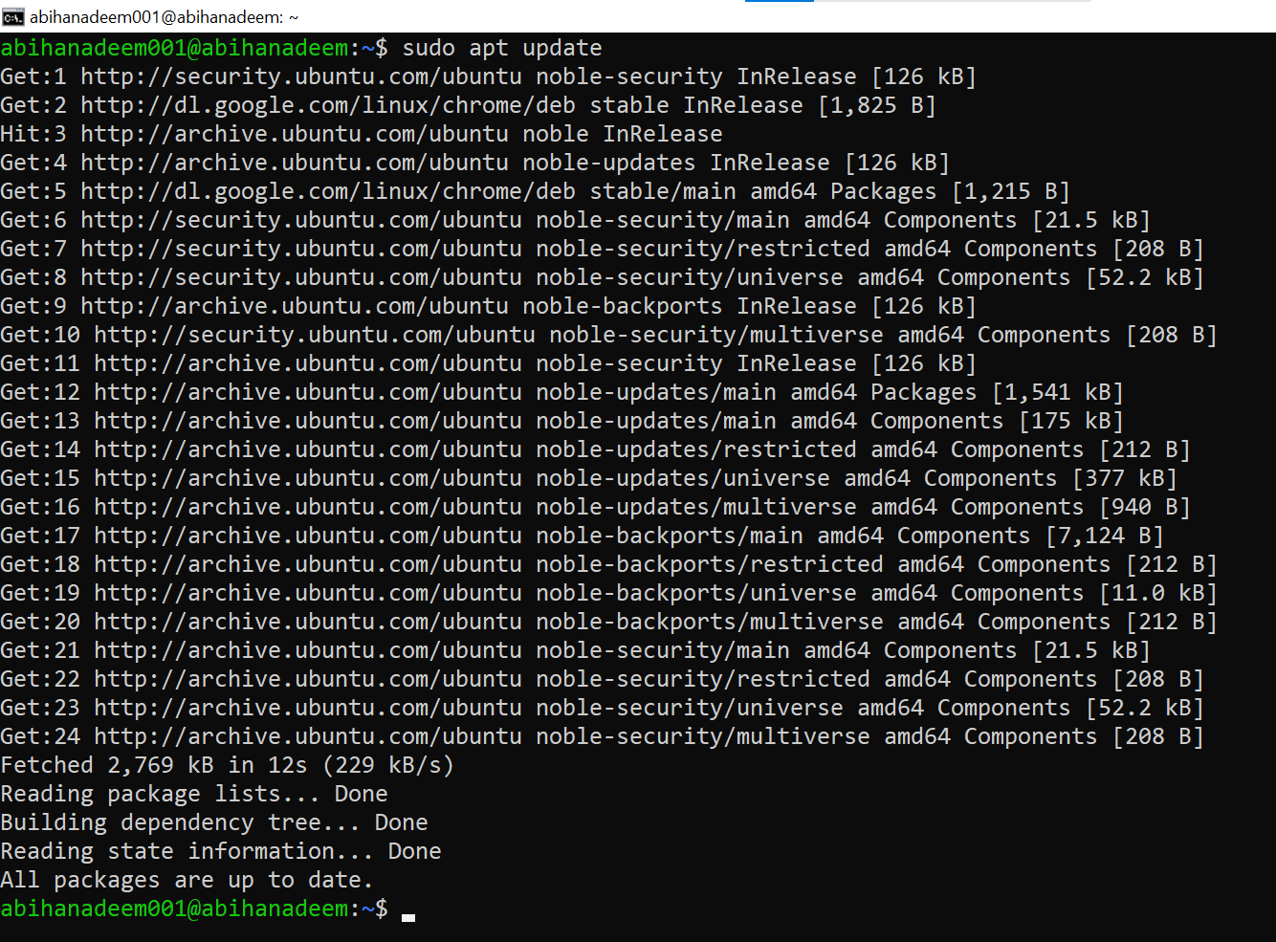

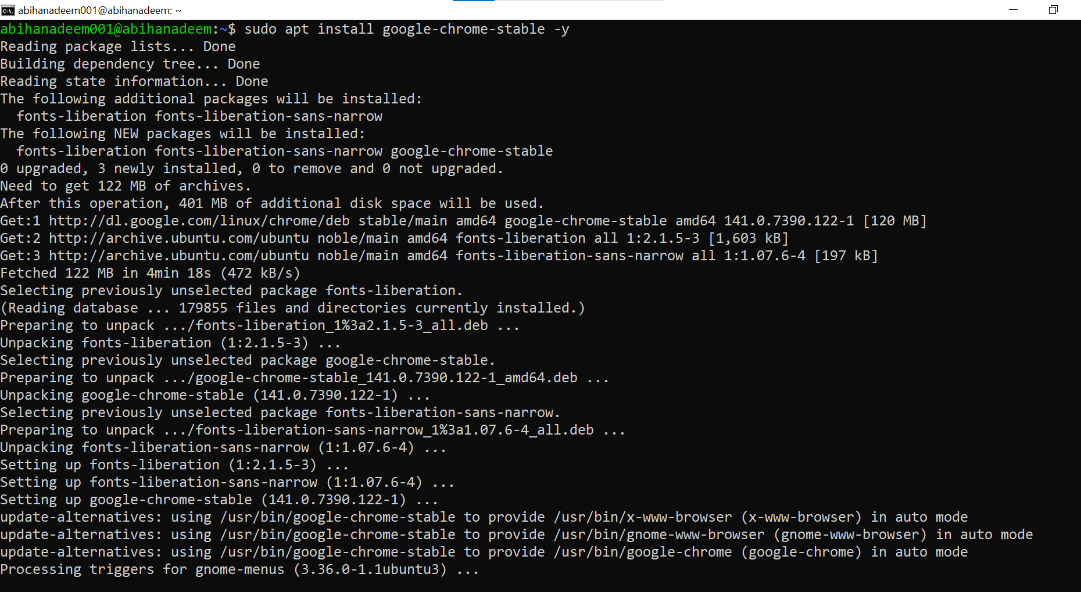

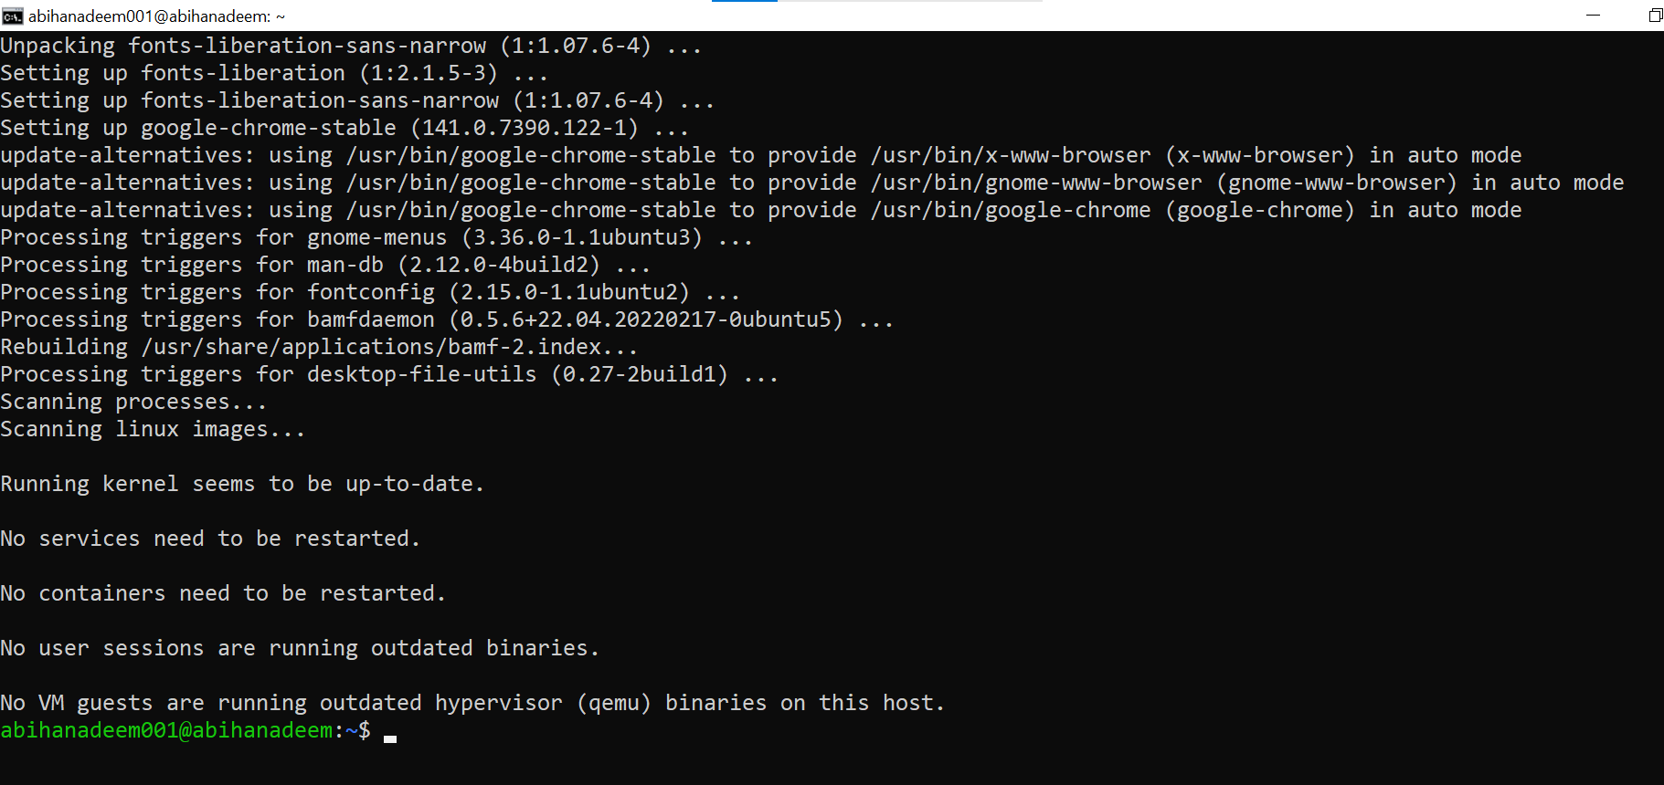

1. Alternate (preferred, cleaner) method — create a single google-chrome.list entry
2. Cleanup before alternate method you added the chrome earlier and want to switch to the preferred method:

sudo apt remove google-chrome-stable -y

sudo nano /etc/apt/sources.list.d/ubuntu.sources # remove the chrome stanza you added earlier, save and exit

sudo rm -f /etc/apt/keyrings/google.gpg

* Save screenshots as: task7_alternate_remove.png, task7_alternate_edit.png, and task7_remove_key.png

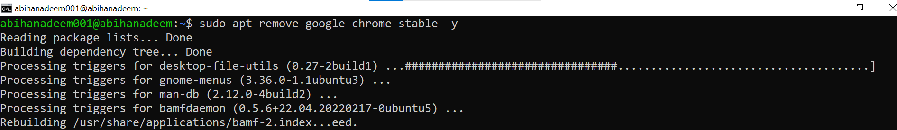

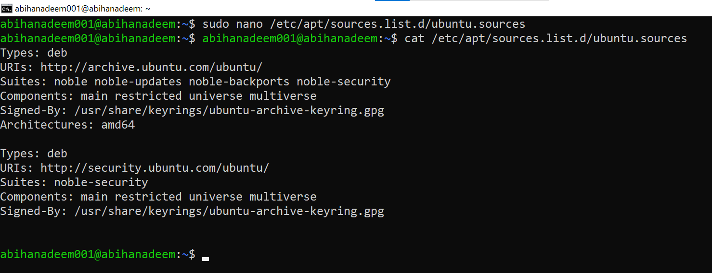

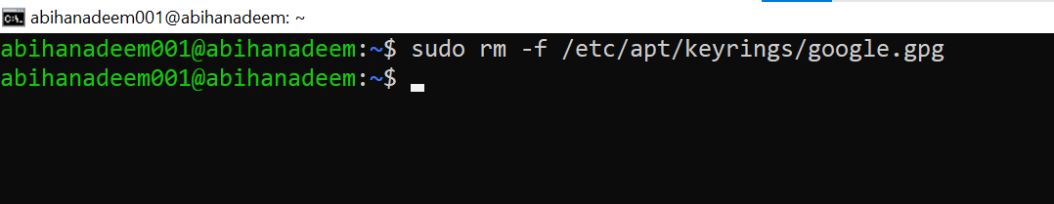

1. Create a dedicated one-line list file for Google Chrome (preferred):

echo "deb [arch=amd64 signed-by=/etc/apt/keyrings/google.gpg] http://dl.google.com/linux/chrome/deb/ stable main" | sudo tee /etc/apt/sources.list.d/google-chrome.list > /dev/null

* Save screenshot as: task7_create_google_chrome_list.png



1. Verify the new file exists:

ls -la /etc/apt/sources.list.d/

* Save screenshot as: task7_list_sources_after_create.png

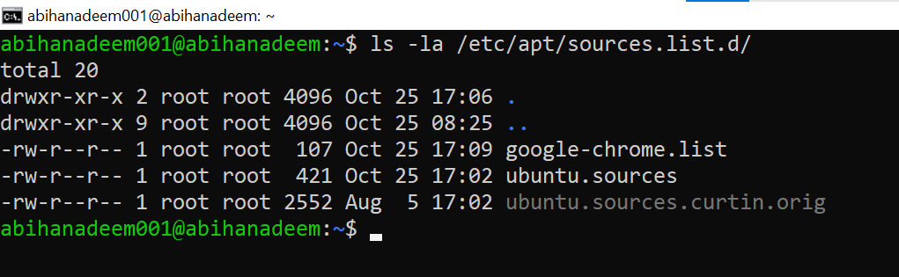

1. Re-add the Google signing key (if removed previously or not present):

sudo mkdir -p /etc/apt/keyrings

curl -fsSL https://dl.google.com/linux/linux_signing_key.pub | sudo gpg --dearmor -o /etc/apt/keyrings/google.gpg

* Save screenshot as: task7_add_key_alt.png



1. Update apt and install Chrome (preferred flow):

sudo apt update

sudo apt install google-chrome-stable -y

* Save screenshots as: task7_apt_update_alt.png and task7_install_chrome_alt.png

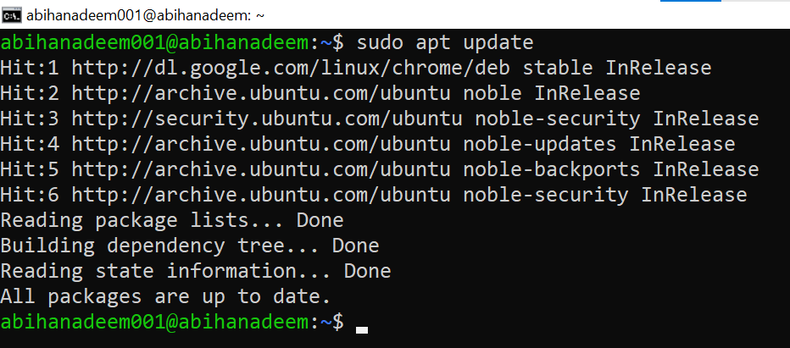

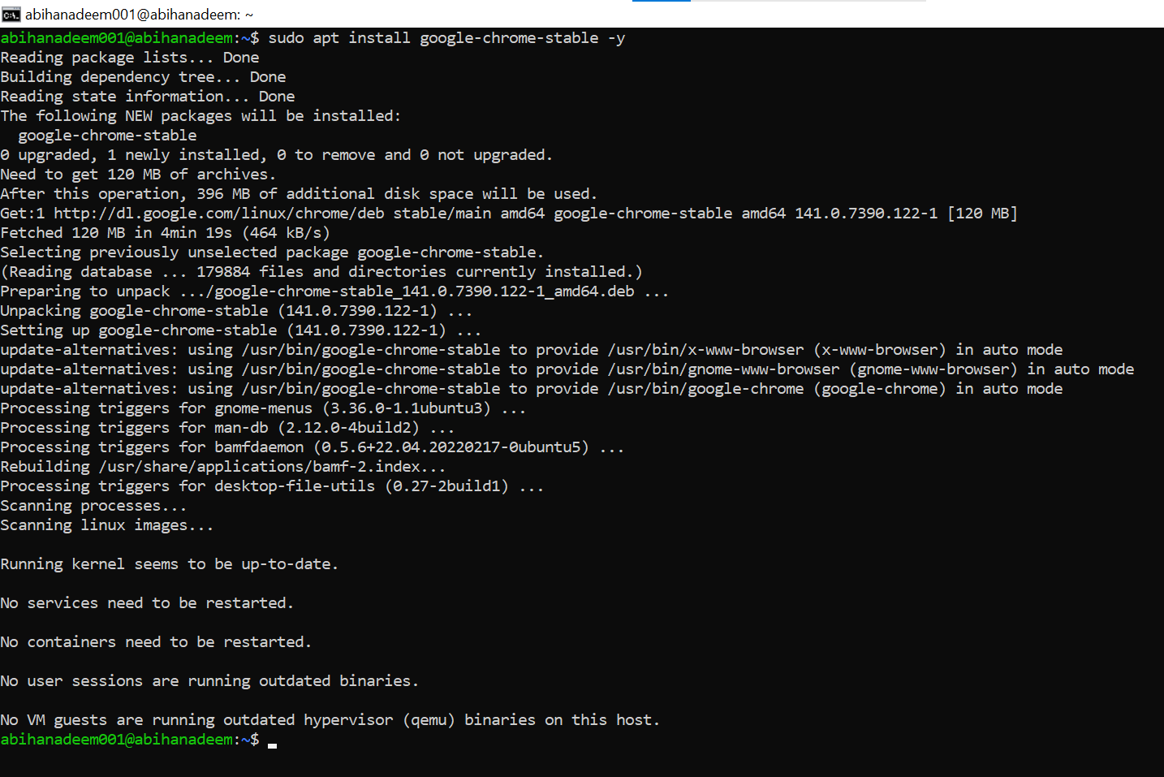

**Task 8 - Install applications via PPA (Audacity & OBS) and launch**

Goal: Add PPAs for Audacity and OBS Studio, update apt, install the packages, and launch them (or verify installation) from the CLI/GUI. Capture screenshots for each step.

NOTE: Performing these steps will add third‑party PPAs to the system. Only add PPAs from trusted sources (these are common community PPAs). If your VM environment restricts PPAs, document any errors.

**Steps (inside the VM terminal or GUI terminal)**

1. Add the Audacity PPA, update apt and install audacity:

sudo add-apt-repository ppa:ubuntuhandbook1/audacity -y

sudo apt update

sudo apt install audacity -y

* Save screenshots as:
  + task8_add_ppa_audacity.png (output of add-apt-repository)

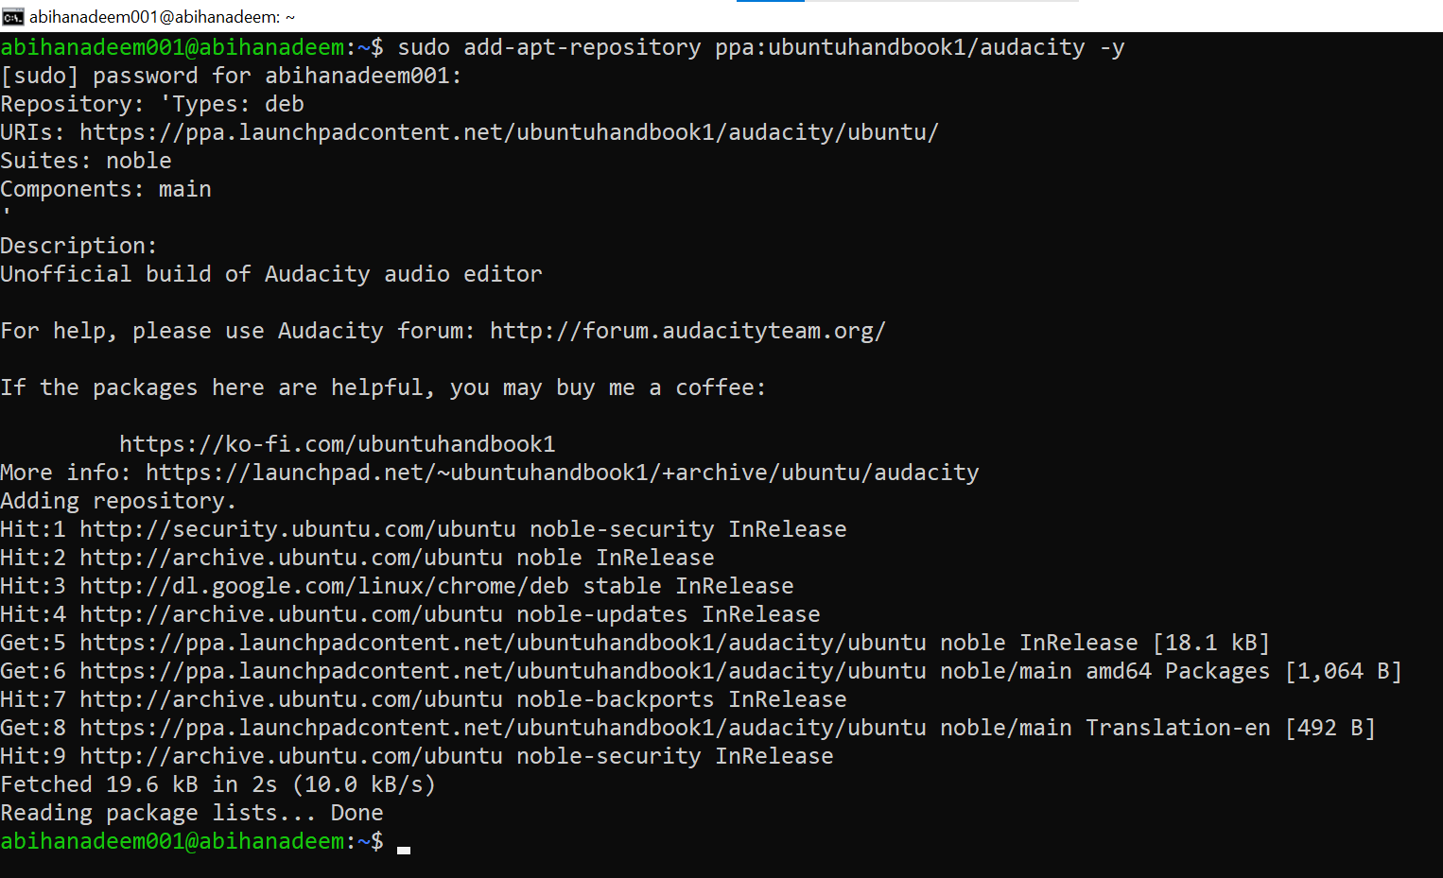

* + task8_apt_update_audacity.png (apt update after adding PPA)

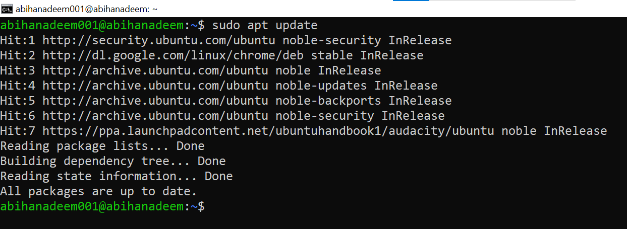

* + task8_install_audacity.png (apt install output)

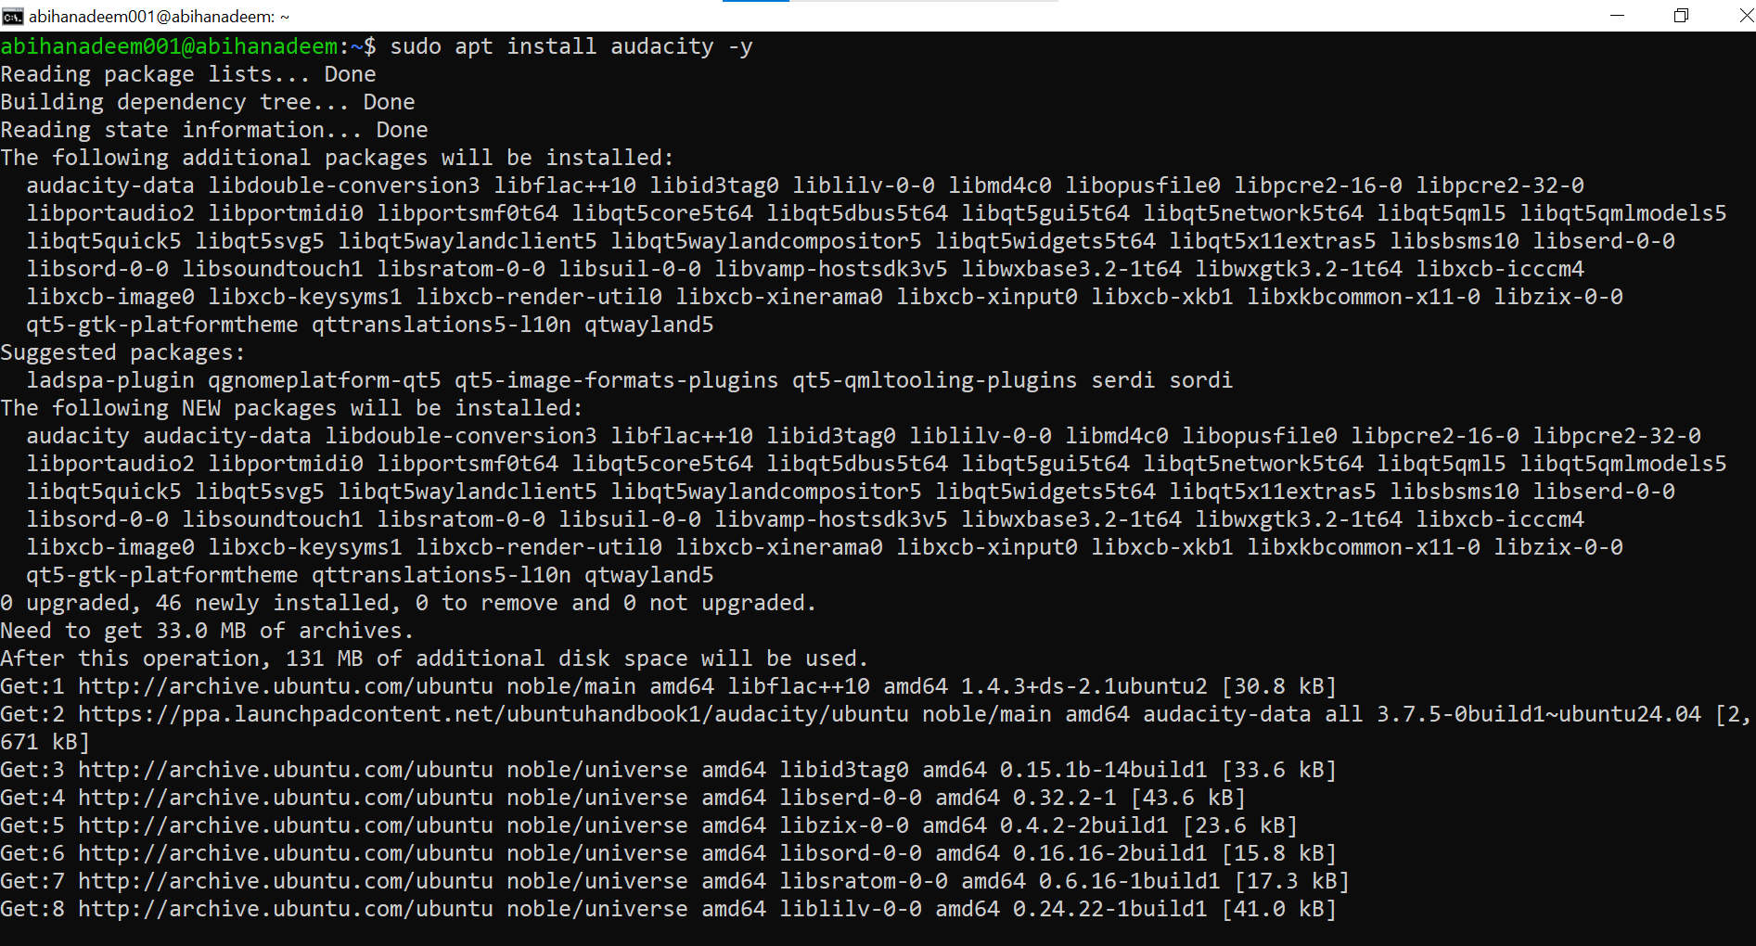

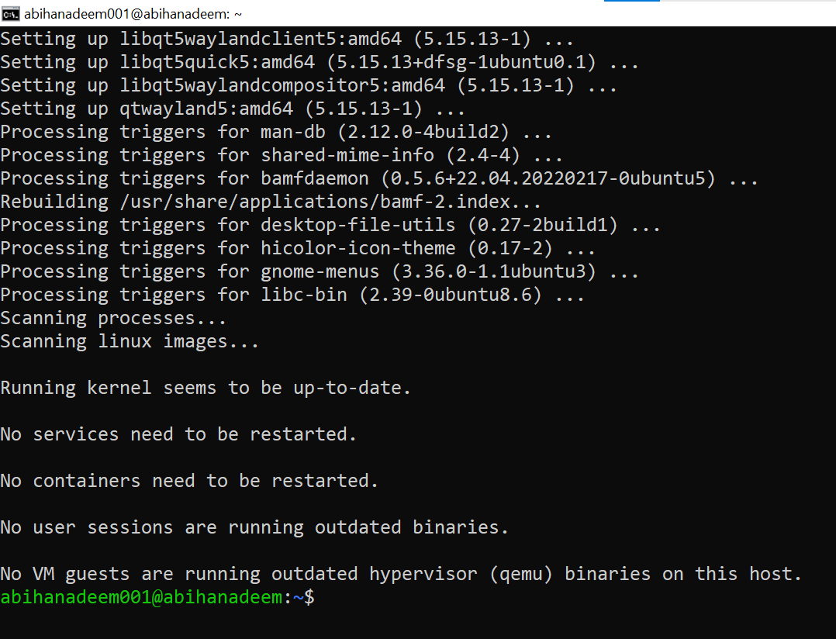

1. Launch Audacity (from GUI or CLI). On a headless server you may not get a GUI window — if you are using the XFCE GUI session, launch from a GUI terminal or run check for binary:

audacity --version

audacity

* Save screenshots as:
  + task8_audacity_launch.png (GUI launch screenshot if possible) or task8_audacity_version.png (CLI verification)

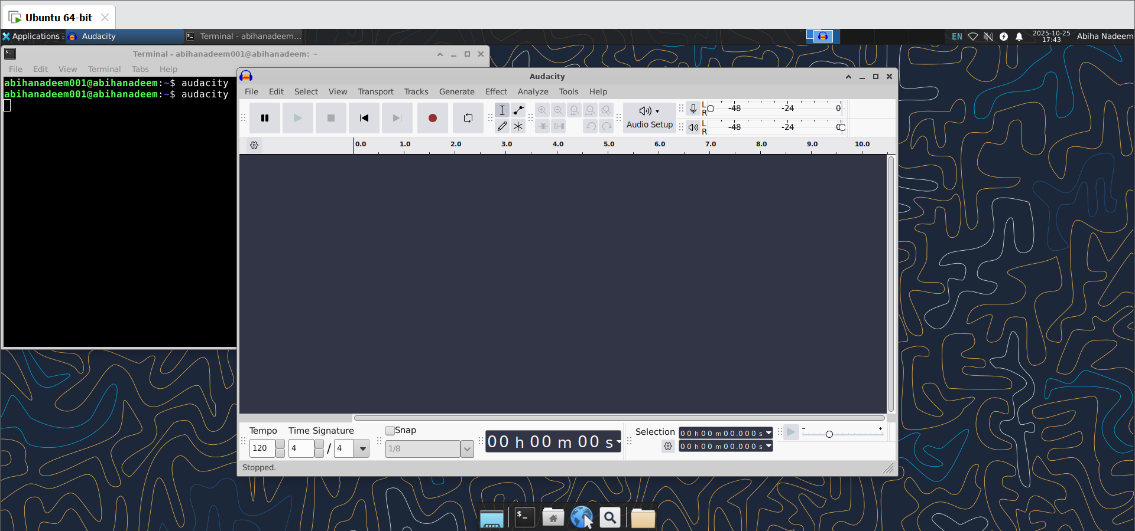

1. Add the OBS Studio PPA, update apt and install obs-studio:

sudo add-apt-repository ppa:obsproject/obs-studio -y

sudo apt update

sudo apt install obs-studio -y

* Save screenshots as:
  + task8_add_ppa_obs.png (output of add-apt-repository)

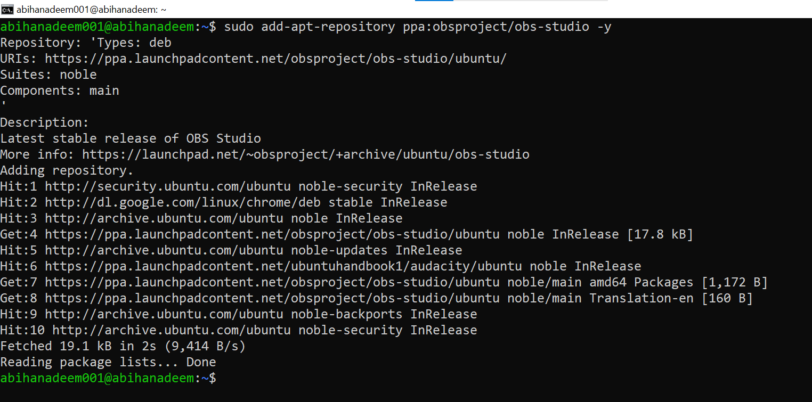

* + task8_apt_update_obs.png (apt update after adding PPA)

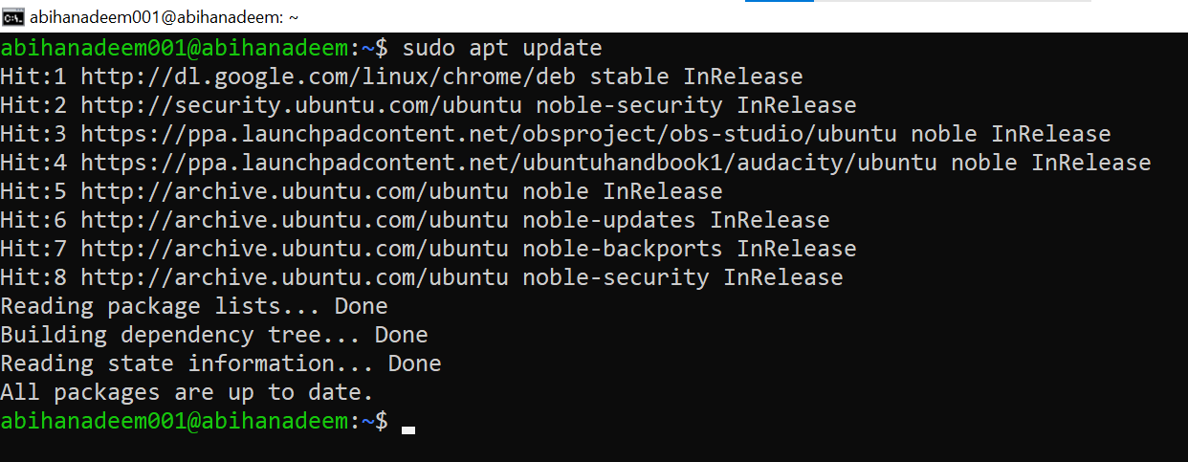

* + task8_install_obs.png (apt install output)

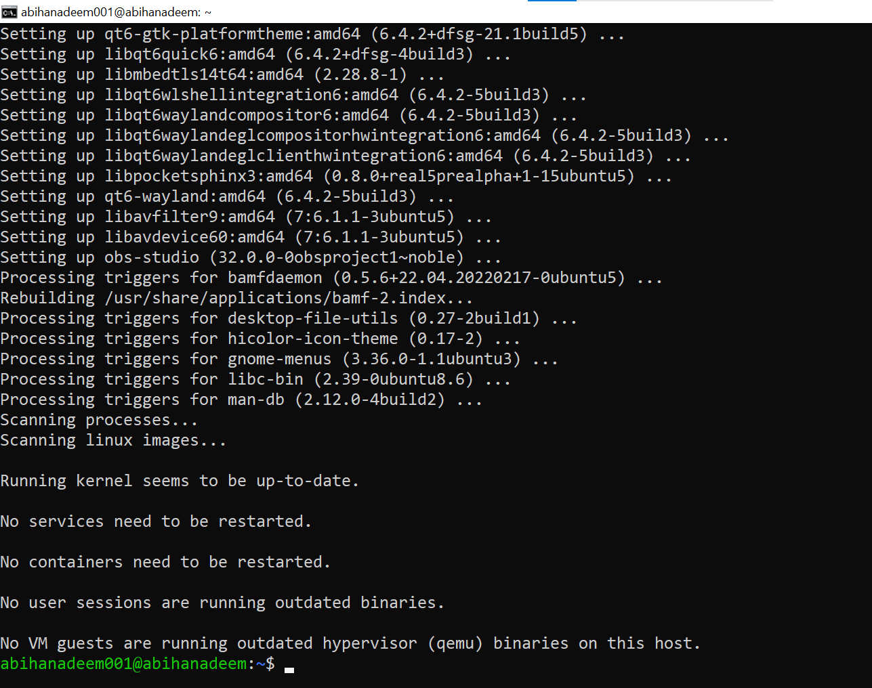

1. Launch OBS Studio (from GUI or verify binary presence):

obs --version

obs

* Save screenshots as:
  + task8_obs_launch.png (GUI launch screenshot if possible) or task8_obs_version.png (CLI verification)

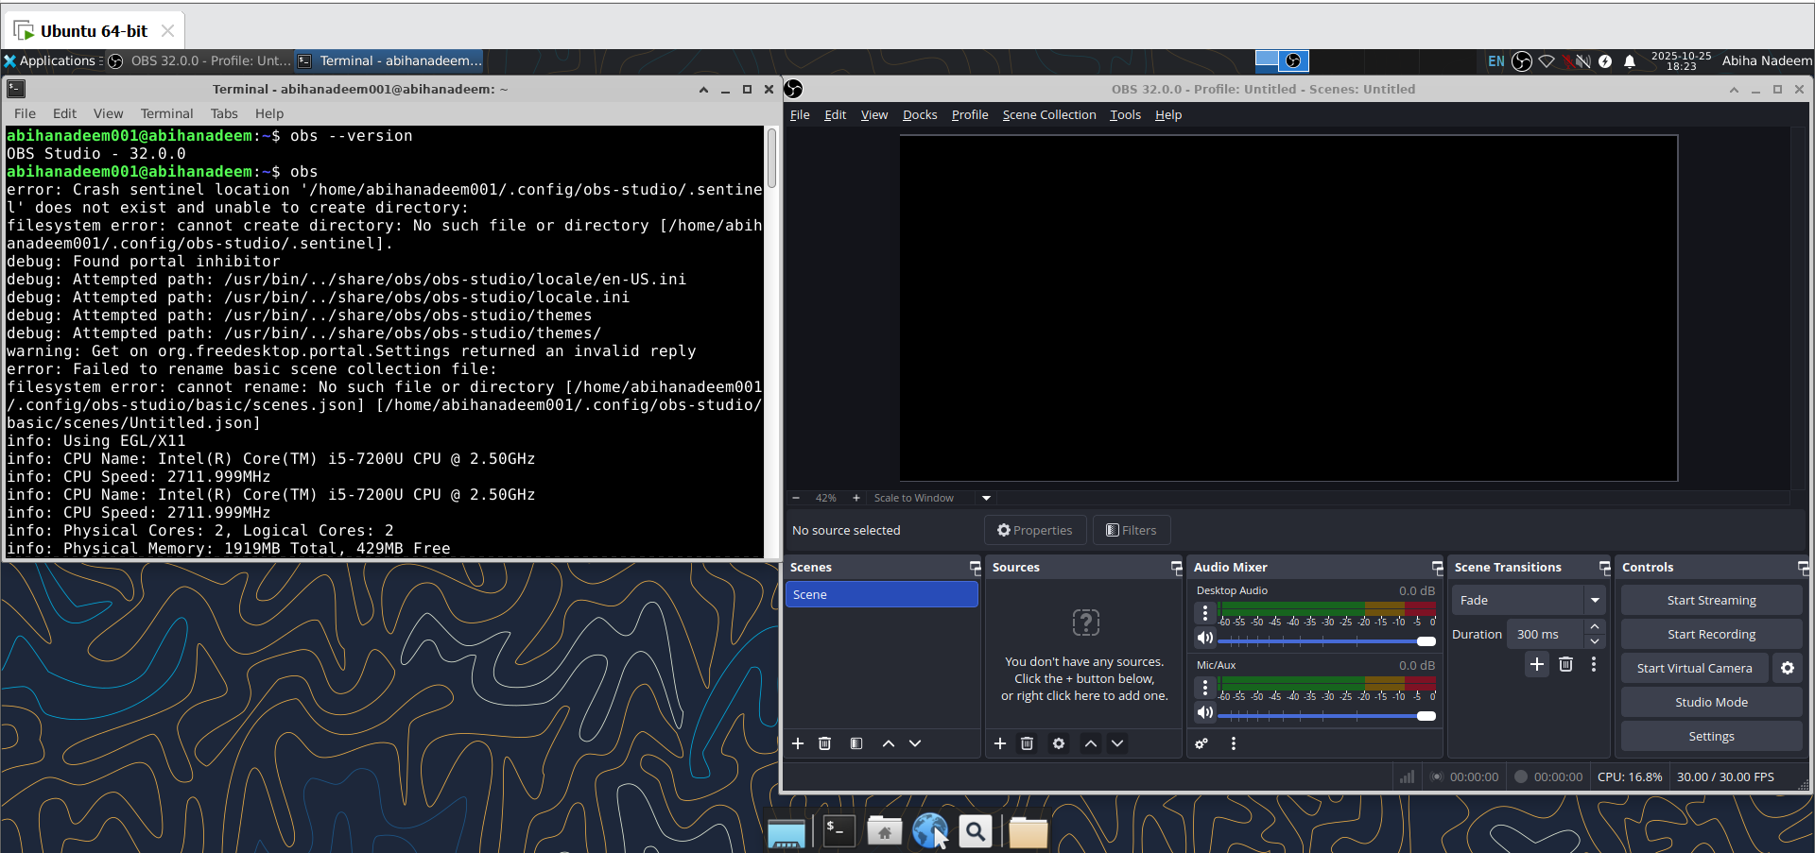

**Task 9 - Create a Kubernetes sample YAML using vim**

Goal: Confirm vim availability, create a working directory for Lab5, and use vim to create and save a Kubernetes Pod manifest named k8s-sample.yaml.

NOTE: The first command in Task 9 is to run vim to confirm whether vim is installed.

**Steps (inside the VM terminal or host terminal / via SSH)**

1. Check whether vim is installed by running:

Vi

* If vim opens, you will see the vim interface; if not installed you will see a command-not-found error.
* Save a screenshot of the result (either the vim splash screen or the error) as: task9_vim_check.png

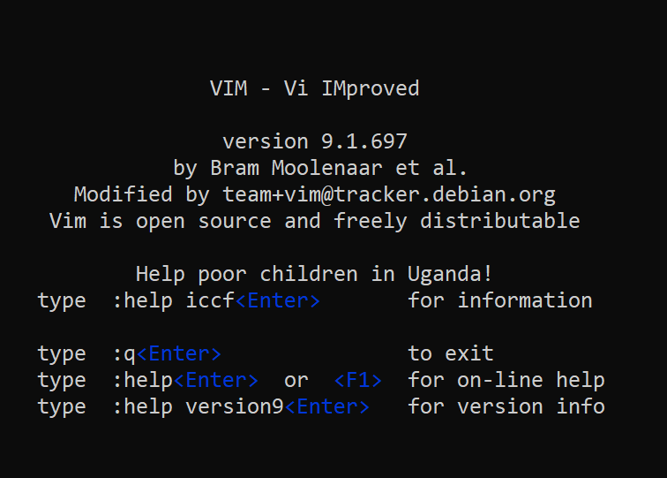

* If vim is not installed, install it:

sudo apt update

sudo apt install vim -y

* Save screenshot of the installation as: task9_vim_install.png (only if you installed it).

1. Create the Lab5 working directory in your home and change into it:

mkdir -p ~/Lab5

cd ~/Lab5

* Save screenshot showing mkdir and cd or pwd output as: task9_mkdir_cd.png

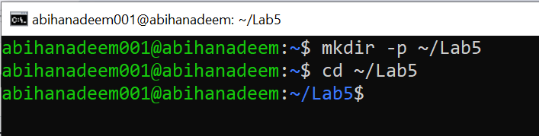

1. Create the Kubernetes sample file using vim:

vim k8s-sample.yaml

* Once vim opens, enable insert mode by pressing i, then paste the following YAML exactly:

apiVersion: v1

kind: Pod

metadata:

name: nginx-pod

spec:

containers:

- name: nginx

image: nginx:1.19

ports:

- containerPort: 80

restartPolicy: Always

* Save a screenshot of the vim editor showing the file contents before saving as task9_vim_edit.png

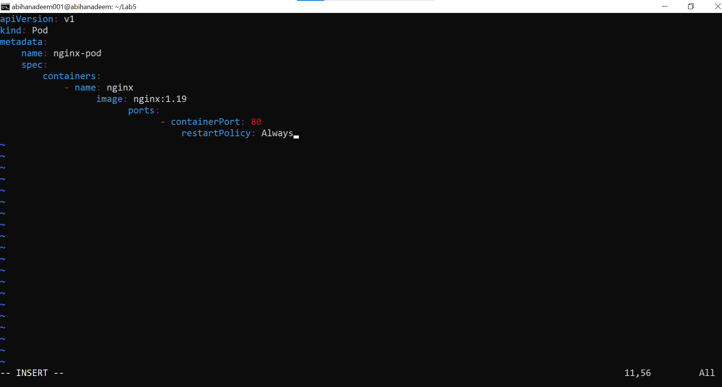

1. Exit insert mode by pressing Esc, then save and quit vim with:

:wq

* Save a screenshot of the ls -la output showing the file exists task9_k8s_saved.png

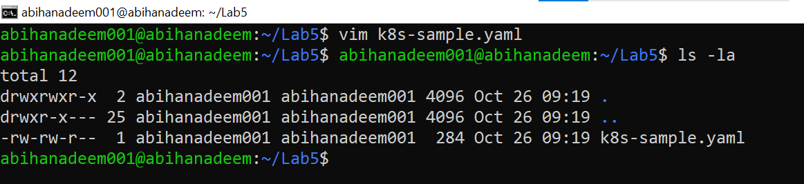

**Task 10 - Edit the Kubernetes YAML - add annotation, verify, then discard temporary change**

Goal: Practice vim edits: add a permanent annotation under metadata, verify it, then open the file again, make a temporary edit and discard it (no save). This demonstrates saving and discarding changes in vim.

**Steps (inside the VM terminal or host terminal / via SSH)**

1. Open the manifest with vim:

cd ~/Lab5

vim k8s-sample.yaml

* When vim opens, ensure you are in command mode (press Esc) then press i to enter insert mode.

1. Add the annotation under the metadata section (indentation must match YAML). Example (insert these lines under metadata:):

annotations:

lab: lesson11

* After adding the lines, press Esc to return to command mode and save & quit:

:wq

* Save a screenshot showing the saved file contents (using cat) as: task10_verify_annotation.png

Example verify command:

cat k8s-sample.yaml

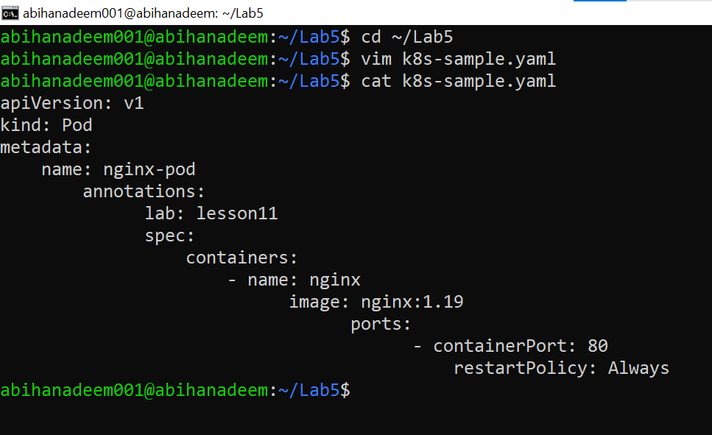

1. Discard changes (practice: make a temporary edit and exit without saving)

* Open the file again:

vim k8s-sample.yaml

* Enter insert mode (i) and add a temporary comment line anywhere, for example:

# temp: do-not-keep

* Save a screenshot showing vim editor having temp data as: task10_verify_entering_temp_data.png

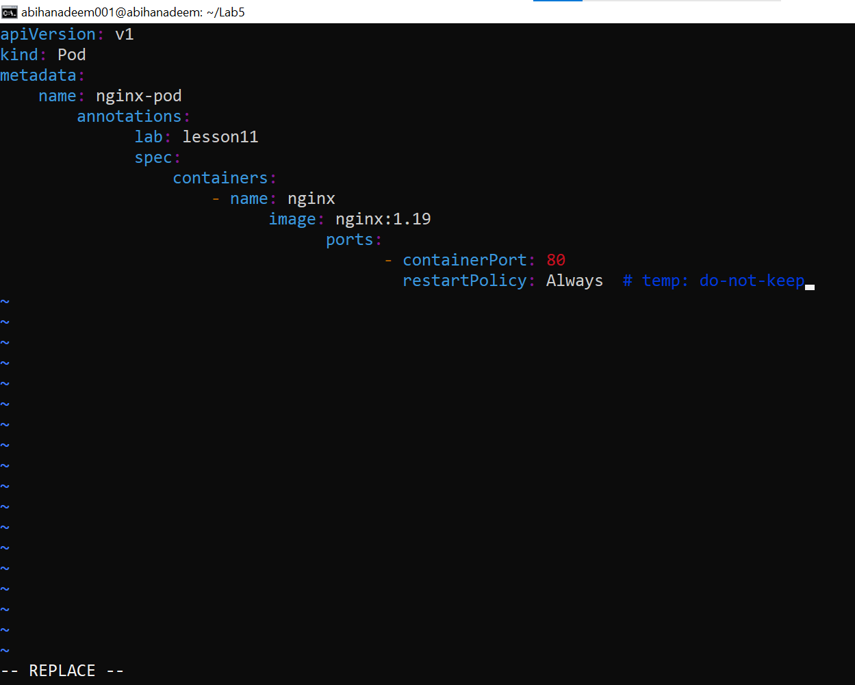

* Do NOT save. Press Esc to go back to command mode, then force quit without saving:

:q!

* Verify the file does NOT contain the temporary comment:

cat k8s-sample.yaml

* Save a screenshot of the cat output proving the temporary comment is not present as: task10_verify_no_temp_comment.png

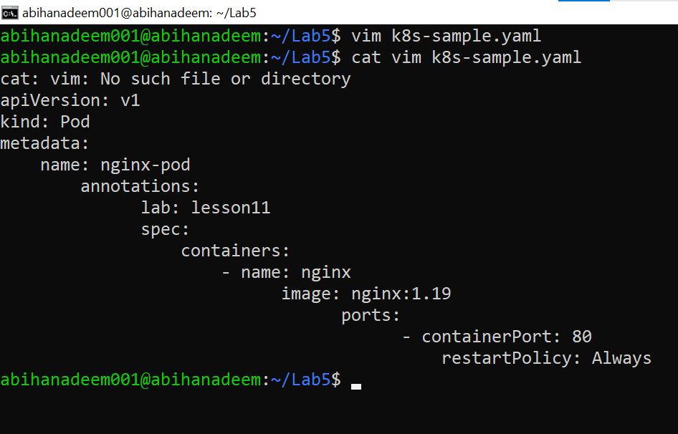

**Task 11 - Vim editing practice - delete, undo, numeric deletes, navigation**

Goal: Practice common vim commands: delete a single line with dd, undo with u, delete multiple lines with a numeric prefix, undo again, and practice basic navigation commands (1G, G, $, 0). Capture verification screenshots showing the file before/after where appropriate.

NOTE: Perform these steps in the ~/Lab5 directory on the previously created k8s-sample.yaml.

**Steps (inside the VM terminal or host terminal / via SSH)**

1. Open the file with vim:

cd ~/Lab5

vim k8s-sample.yaml

1. Delete the line containing image: nginx:1.19 with a single command:

* Ensure you are in command mode (press Esc), move the cursor to the line with image: nginx:1.19, then delete that line with:

dd

* Immediately undo the deletion with:

u

* Capture a screenshot showing the file after the undo (or a cat output after saving) as: task11_dd_delete_and_undo.png

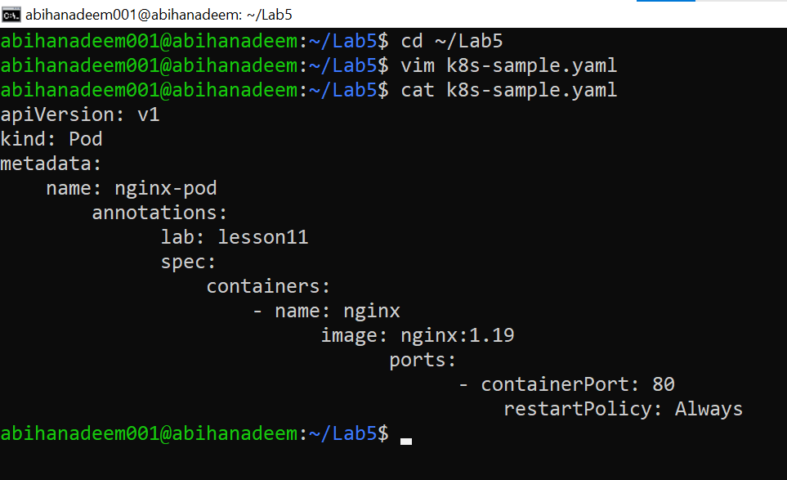

1. Delete 3 lines at once using the numeric delete command:

* In command mode, position the cursor on the first line of the three you want to delete (for example start at the image: line again), then run:

d3d

(or 3dd or d3<enter> — either numeric prefix form is acceptable; document which you used)

* Immediately undo the deletion with:

u

* Capture a screenshot showing the file after the undo (or a cat output) as: task11_delete3_and_undo.png

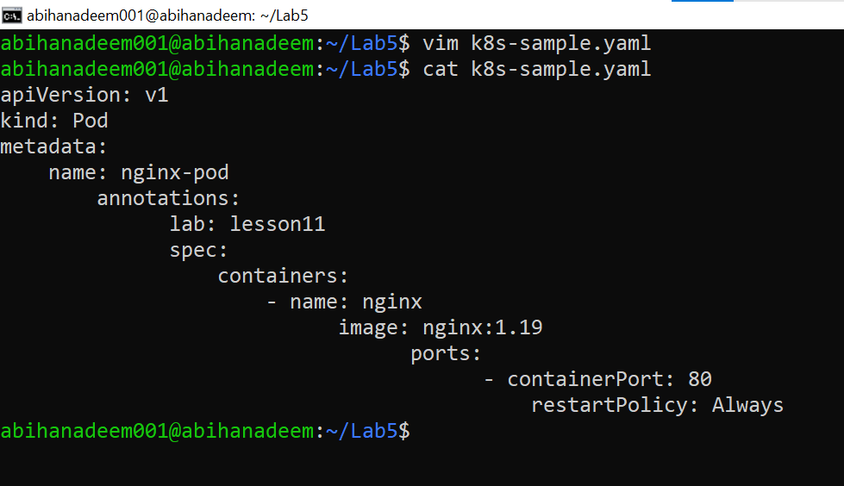

1. Navigation practice (from command mode)

* Jump to the first line:

1G

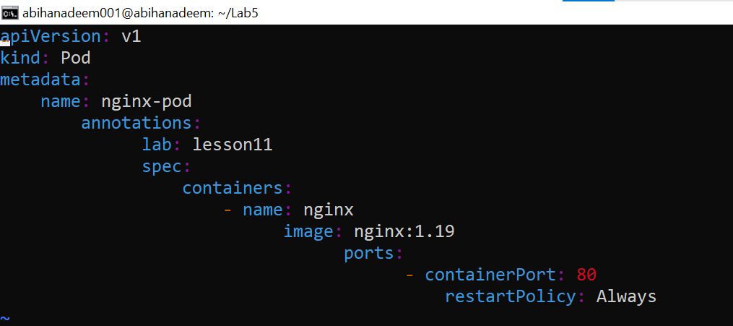

* Note the line contents capture a screenshot saved as: task11_line1.png
* Jump to the last line:

G

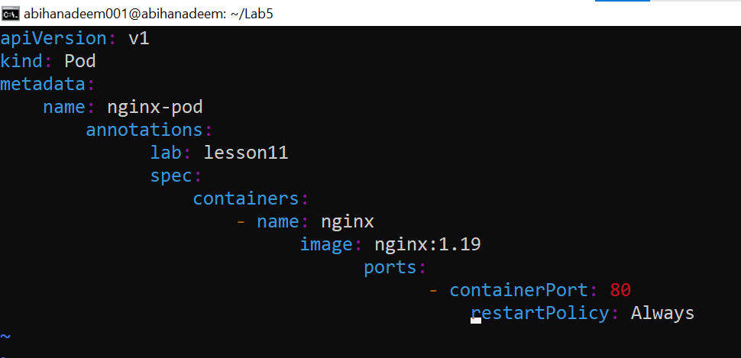

* On the line containing containerPort: 80 press $ to move to end of line, then 0 to move back to the start of the line. Capture a brief terminal screenshot showing you on the line and the commands capture the screenshot as: task11_navigation.png

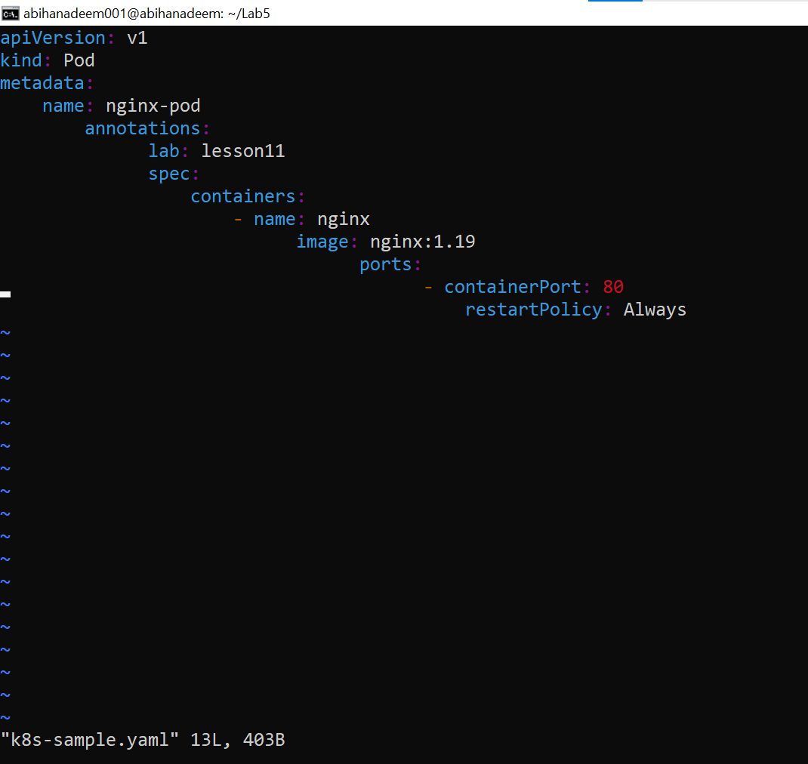

1. Exit vim (no changes should remain if you undid properly):

:q

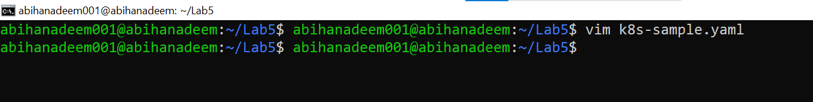

**Task 12 - Vim search, add matches, substitute, undo**

Goal: Practice searching in vim with /, navigate matches with n and N, add additional matches, substitute across the file, undo, and exit without saving. Capture screenshots to show each verification step.

NOTE: Perform these steps in the ~/Lab5 directory on the previously created k8s-sample.yaml.

**Steps (inside the VM terminal / in the ~/Lab5 directory)**

1. Open the file with vim:

cd ~/Lab5

vim k8s-sample.yaml

1. Search for the string nginx using the forward search command:

* From command mode type:

/nginx

and press Enter.

* Note the first match is highlighted and the cursor is placed on it. Save a screenshot showing the first match in vim as: task12_search_nginx.png

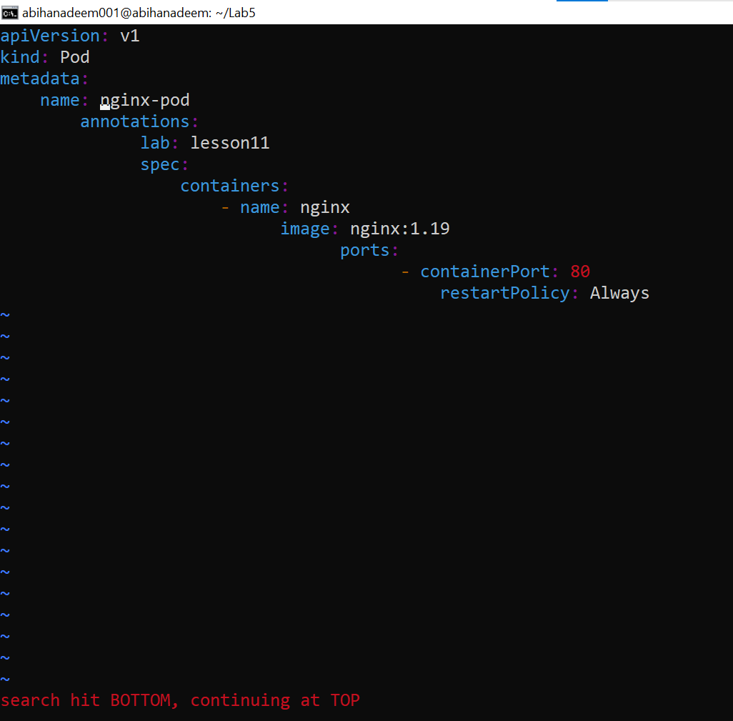

1. Move to the next match and previous match:

* Press n to jump to the next match (capture screenshot if desired) and press N to jump back to the previous match. Save a screenshot showing navigation between matches as: task12_n_and_N_navigation.png

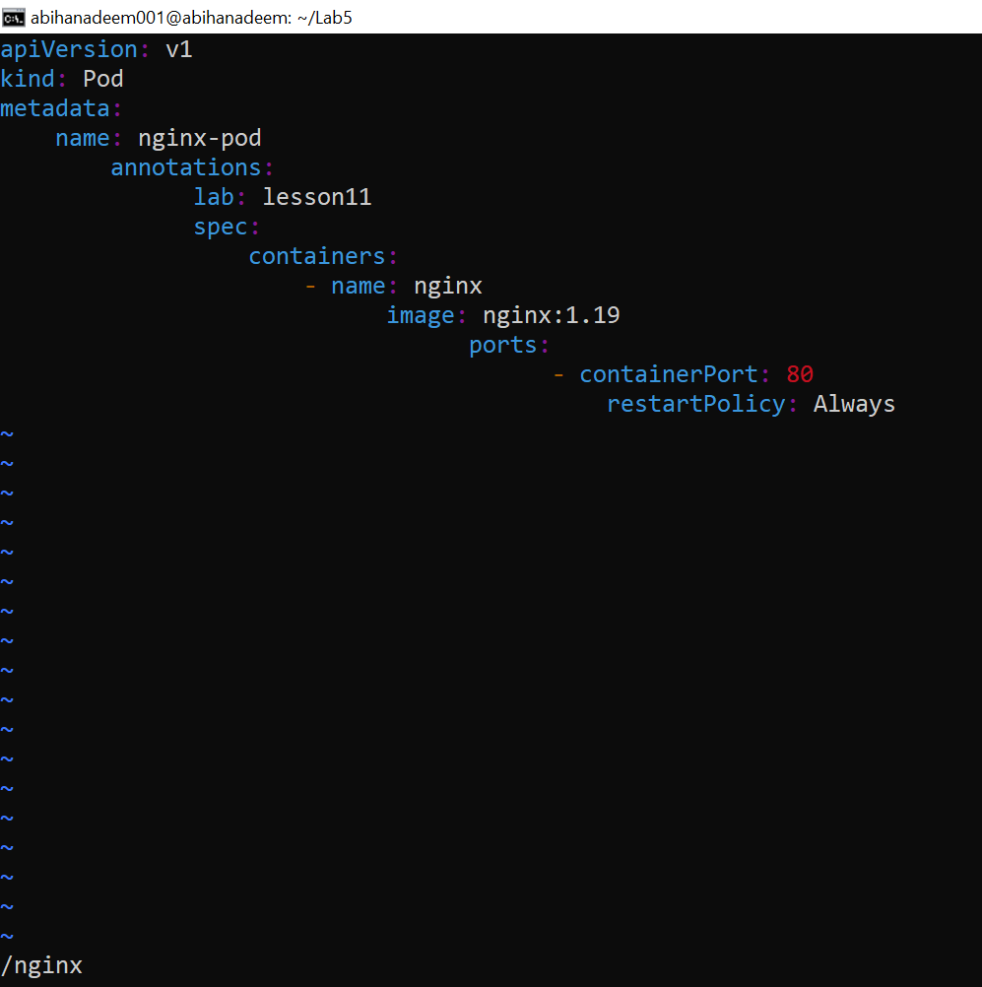

1. Add two more occurrences of the word nginx in the file:

* Enter insert mode (i) at an appropriate place (for example add two new comment lines or add them under metadata as comments), type two new occurrences of nginx, then press Esc to return to command mode and save the file with :w.
* Save a screenshot showing the added occurrences (or cat output) as: task12_added_occurrences.png

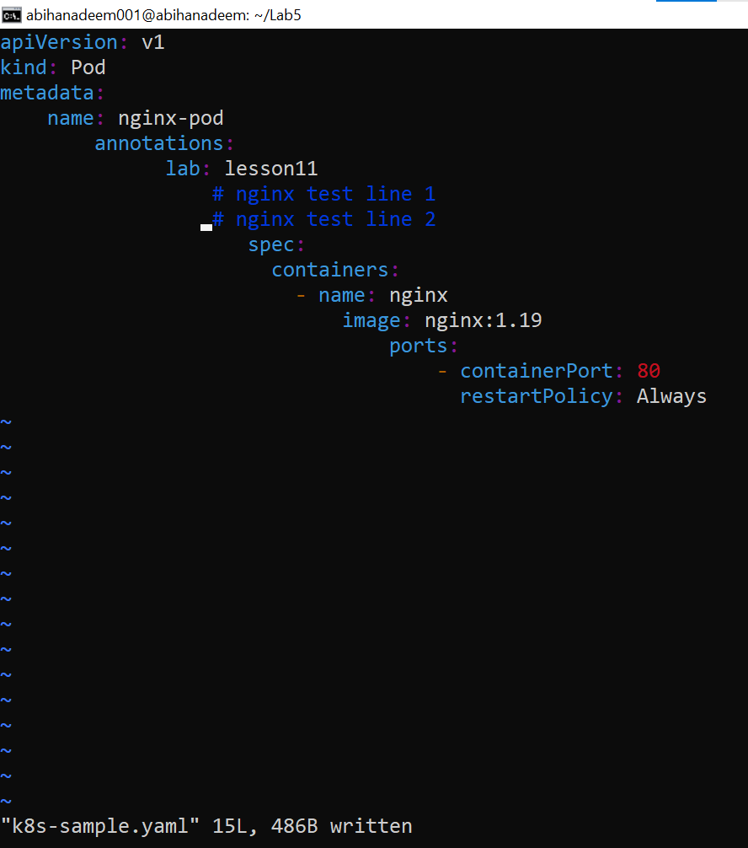

1. Demonstrate that n cycles forward through all matches:

* In vim command mode press /nginx Enter, then repeatedly press n to cycle forward through each match. Capture a short sequence (or a terminal screenshot showing the cursor on a later match) as: task12_cycle_matches.png

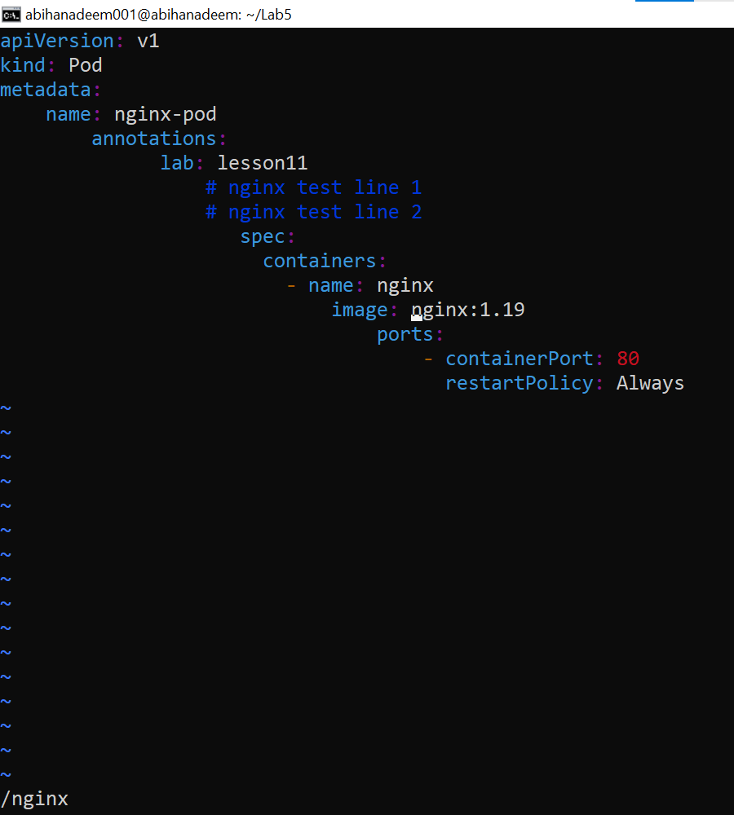

1. Substitute all occurrences of nginx with webapp:

* From command mode execute the substitute command:

:%s/nginx/webapp

* This will replace all occurrences in the file (note: this changes the buffer). Save a screenshot showing the substitution result (or cat k8s-sample.yaml) as: task12_substitute_result.png

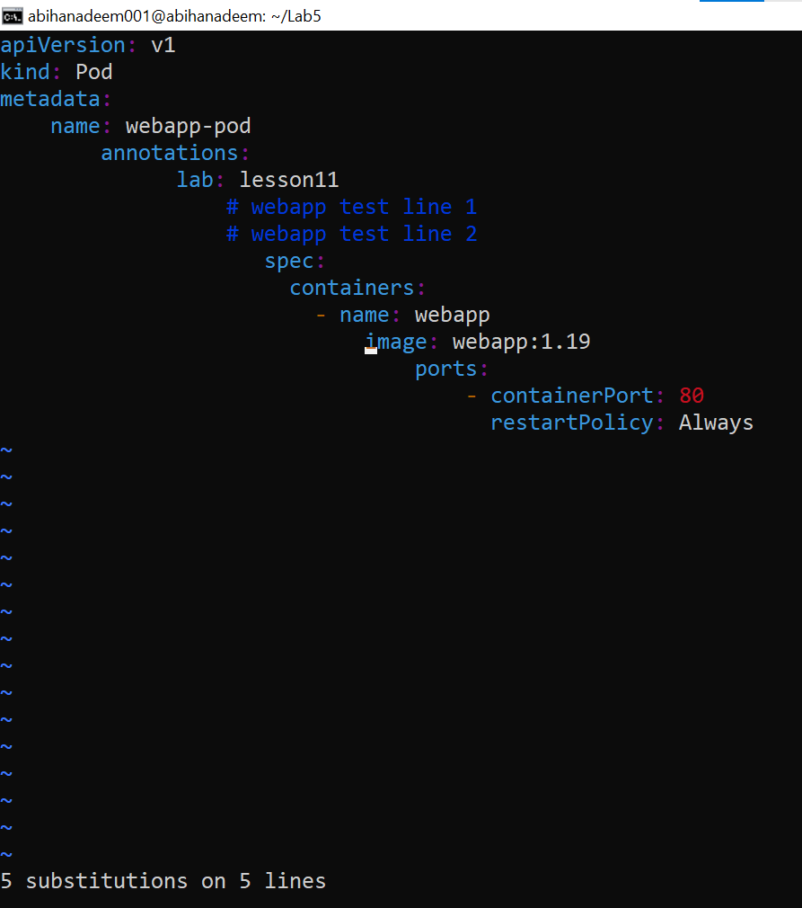

1. Immediately undo the substitution using u:

* Press u in command mode to undo the last change. Save a screenshot showing the file restored to the previous state as: task12_undo_and_quit.png

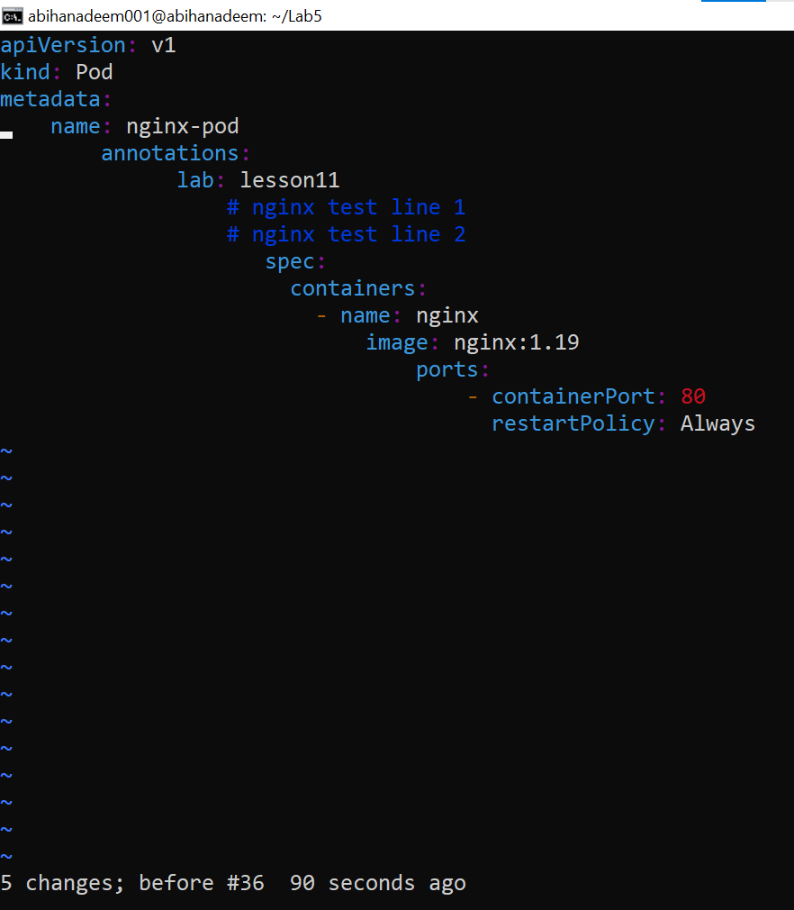

1. Quit vim without saving any accidental changes (if you didn't already save after substitution and want to discard):

* If you want to ensure no changes were written, exit with:

:q!

* If you intentionally saved the substitution and then undid it and wish to quit normally, use :q.

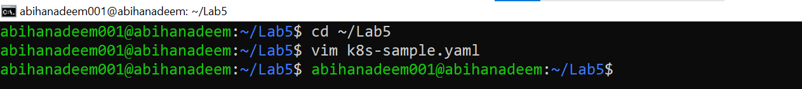

**Exam Evaluation Question**

Goal: This is an exam-style evaluation prompt. Students are asked to install Docker Desktop as part of the evaluation exercise on VM. No commands, solutions, hints, or step-by-step instructions are provided here — install Docker Desktop using your own knowledge and research.

Instructions for students:

* Install Docker Desktop on your VMWare Workstation Ubuntu Server. No commands or solutions are provided in this lab — treat this as an evaluation/exam question.
* Verify Docker Desktop is installed by launching the Docker Desktop application and confirming it runs.
* Capture a screenshot of Docker Desktop running (or other clear evidence that Docker Desktop is installed and started) and save it as: exam_evaluation_docker_desktop.png

Notes:

* This task intentionally provides no commands, package names, or step-by-step instructions. You must research and determine the correct installation steps for your OS/environment.



